Curriculum Update: Rainbow Spring 1 - 2024

Topics: Winter , Artic , Chinese New year & Tranport 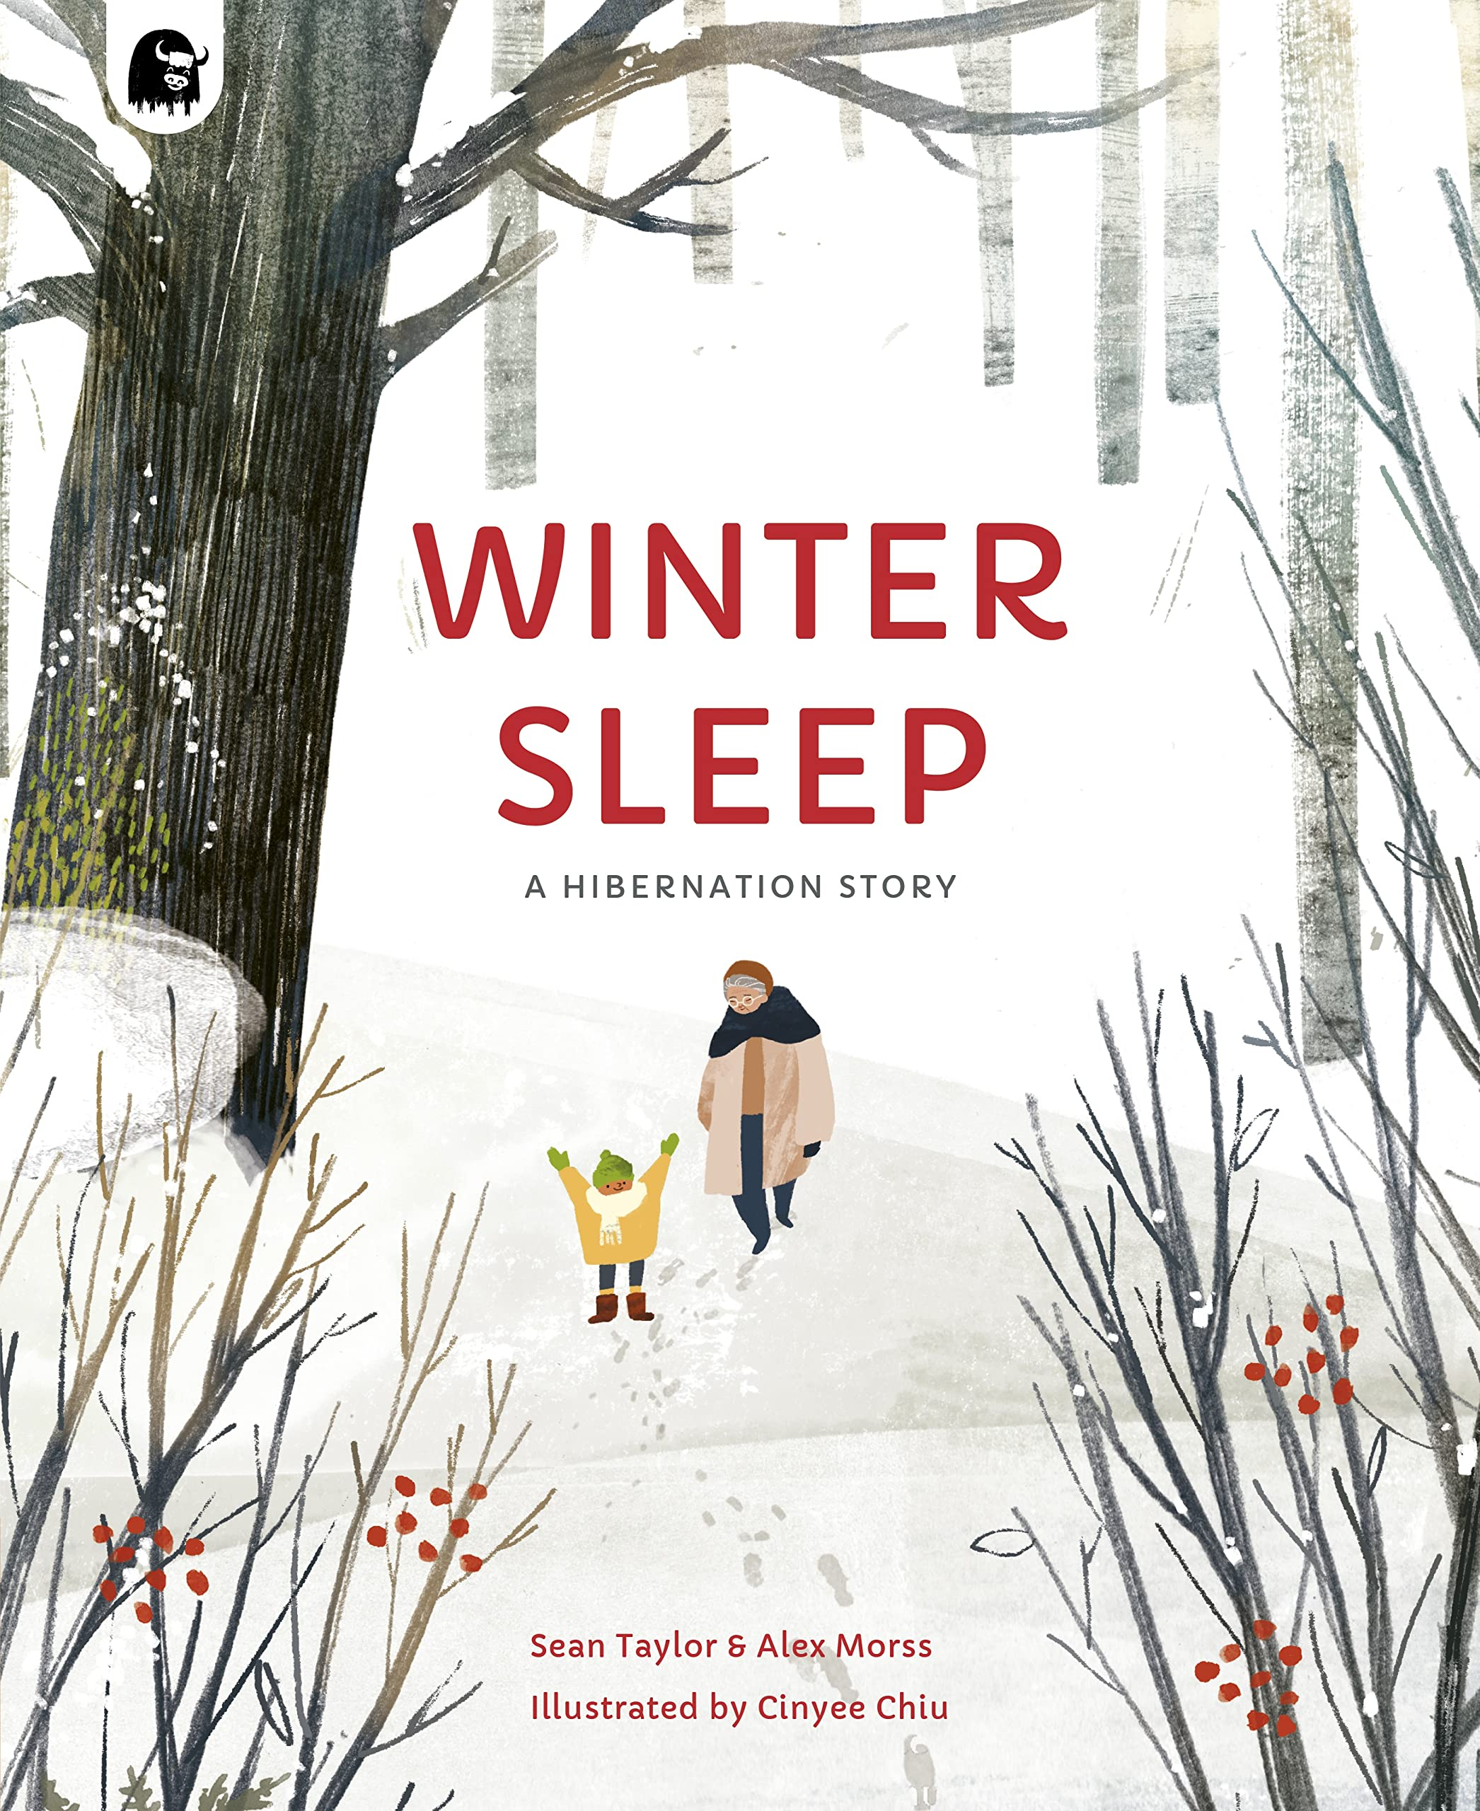   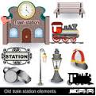
Personal, social and Emotional Development:
We will encourage the children:
To become more outgoing towards unfamiliar people and more confident in new social situations. To relate to their learning powers and recognise when they use them. To describe themselves in positive terms and talk about their abilities. To understand that their actions affect other people, and that they should try to comfort another child when they realise they have upset them.

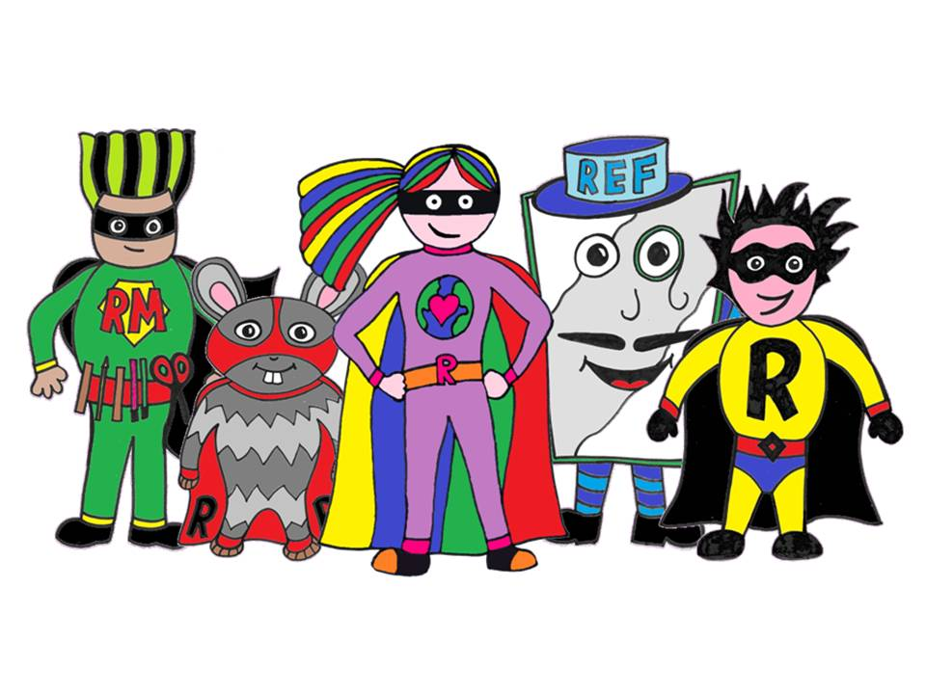

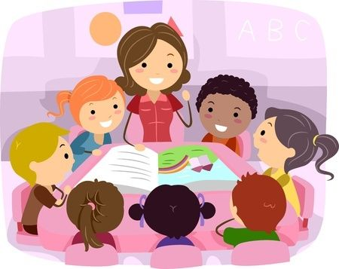
Communication and Language:
We will encourage the children to continue to listen attentively to others in a range of situations and to share their own experiences with the class.
Physical Development:
This term the children will use the wall and floor apparatus. They will develop their skills in climbing, jumping and swinging.
We will continue to encourage the children to hold a pencil effectively to form recognisable letters, most of which are correctly formed.

Mathematics: We are continuing our Maths mastery by working using their sibitising, comparison, counting, ordinality and cardinality and composition skills.
We will be working with the Number blocks and become more familiar with the terms, “fewer than, more than, the amount of.
Understanding the world:
~ The children will become familiar with some features in their local environment, shops, library.
~ observe the features of winter.
~ compare two different landscapes, Artic-Great Britain.
~ learn about the Chinese culture.
~ The children will visit St Denys train station.
~The children will use the laptops and interactive smart board to support their learning.

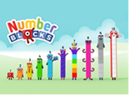

Literacy:
~Reading: The children will be encouraged to read simple words and sentences using their growing phonological awareness.
~ Writing: The children will be encouraged to use their phonic knowledge to write words in ways which match their spoken sounds. ( lots of phonetic sentence writing)


Expressive arts and design:
The children will sing a variety of songs linked to our topics and will continue to use simple percussion instruments and explore their sounds.
There will be opportunities for junk modelling linked to maths work on 3d shapes.

What you can do at home to support your child:
Continue to read together daily, encourage your child to use their knowledge of letter sounds to decode unknown words.

Go on the Bug club website and play the games!

Practise the tricky words by sight: the, go, in, the, no I, are, was, all, me, she, he, said.

Important dates:
Chinese New Year topic day: 9th of February 2024

Miss Nelis & the Rainbow Team.

