Curriculum Update: Rainbow Autumn 2 - 2023
Topics:
Nocturnal animals – Different habitats – Family celebrations - Christmas
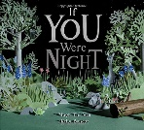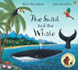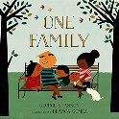
Personal, social and Emotional Development:
We have started to become more familiar with the class room routines and are now encouraging the children to take more ownership of their class room and become more independent in getting themselves ready for all the activities.
We will give them every opportunity to explore all learning areas and make the class as their own.

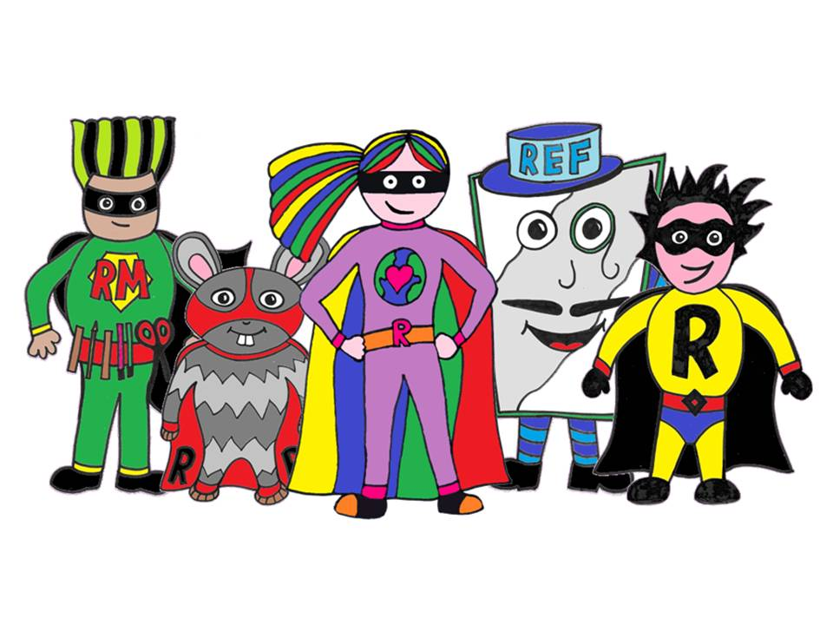

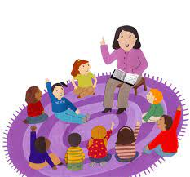
Communication and Language:
We are encouraging the children to share share their ideas and practise their listening skills by being together sharing stories, rhymes and sing songs.
We are also talking about team work and how we can work together to help each other.
Physical Development:
We have started our PE sessions on Thursdays with Mr Fielder and Mrs Sherliker on Fridays. The children will be practicing their balancing skills, travel around the space in different ways and improve their core strength.
The children will visit the Safari zone daily and be out on our Rainbow playground.
(core strengthening, balancing, gross and fine motor skills)

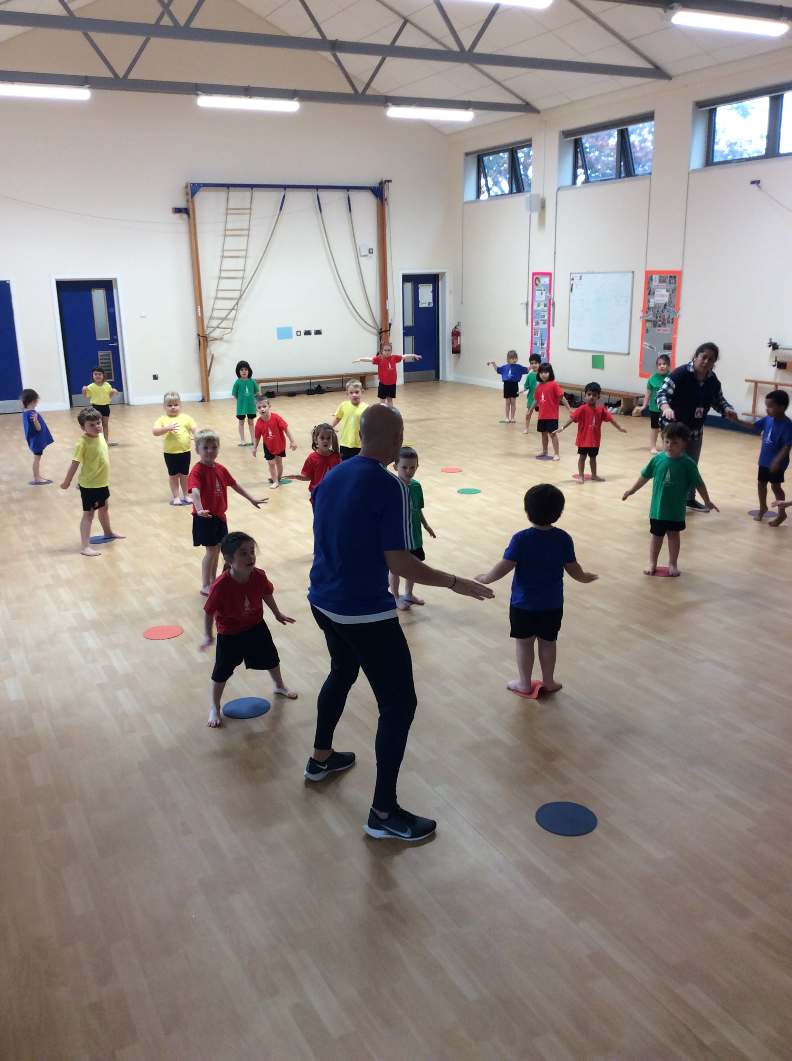
Mathematics:
The children will explore the Maths corner and practise their subitising skills. They will be encouraged to use positional language, compare objects and have a go at putting things in the right order.
Understanding the world:
The children will become familiar with the school grounds, the school building and the local area they live in.
We will look at our surroundings and how they change during the Autumn season.
The children will celebrate Harvest and explore healthy eating.
We will learn about nocturnal animals.

Literacy:
We will be reading lots of stories together, share ideas about the pictures, understand the meaning of text and will start to explore our name letters.
The children will start their Phonics programme “Bug Club” and learn the phase 2 letter sounds.

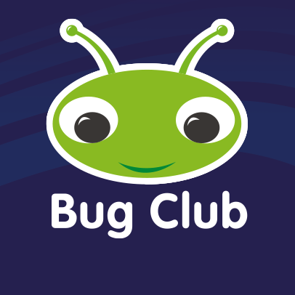

Expressive arts and design:
The children will join in with nursery rhymes and sing a variety of songs linked to our topics.
They will explore loud and quiet sounds and use their body as an instrument.
We will create lots of opportunities for the children to use the art area for junk modelling, painting and all sorts of other crafts.
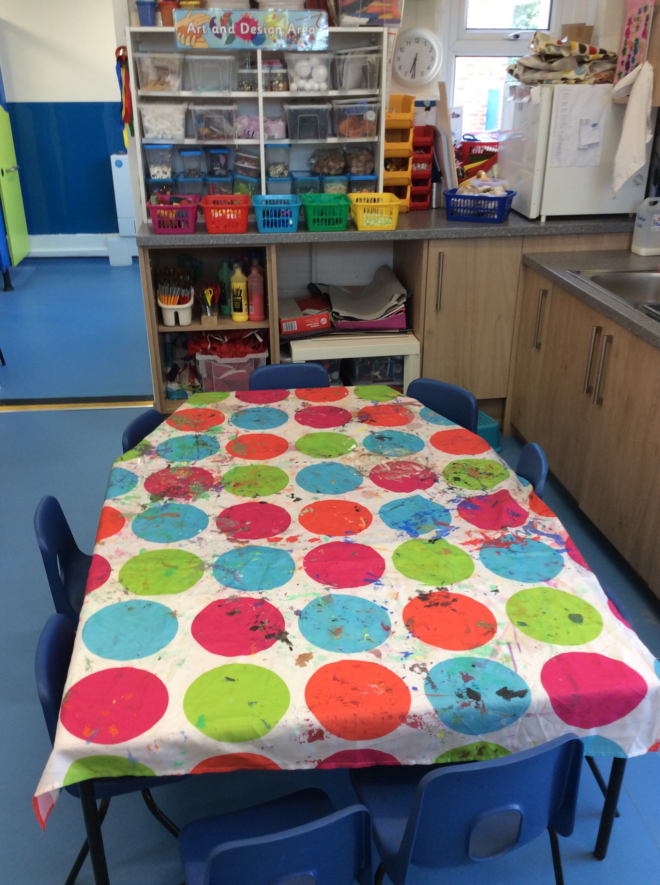
Check list to take to school:
PE shorts + bag
Book bag
Water bottle

And a big smile!

Don’t forget to sign up for Class dojo and check it regularly!

Miss Nelis & the Rainbow Team.

