Curriculum Update: Rainbow Autumn 1 - 2023

Topics: The Colour Monster, Autumn, Harvest & Nocturnal animals
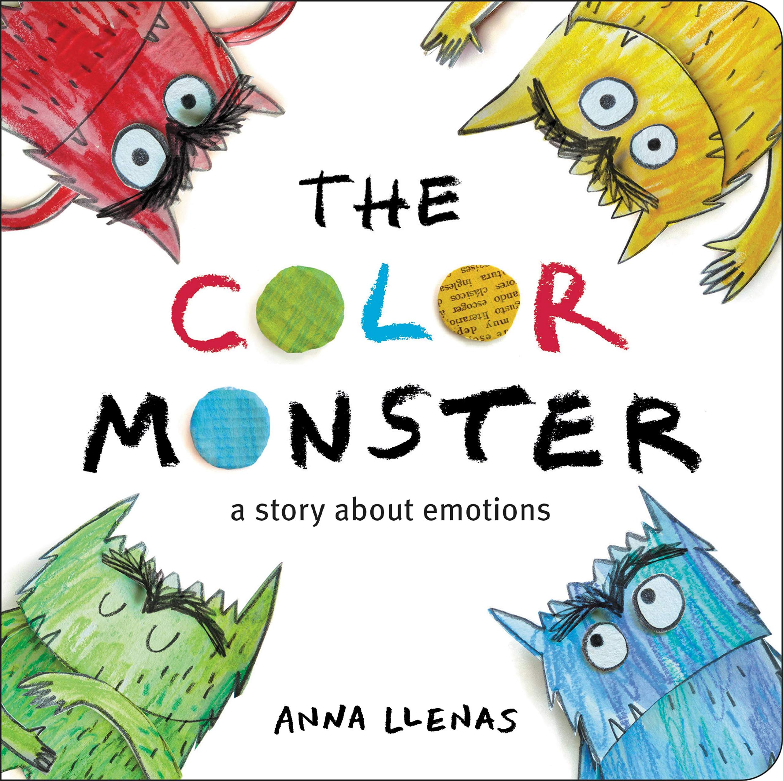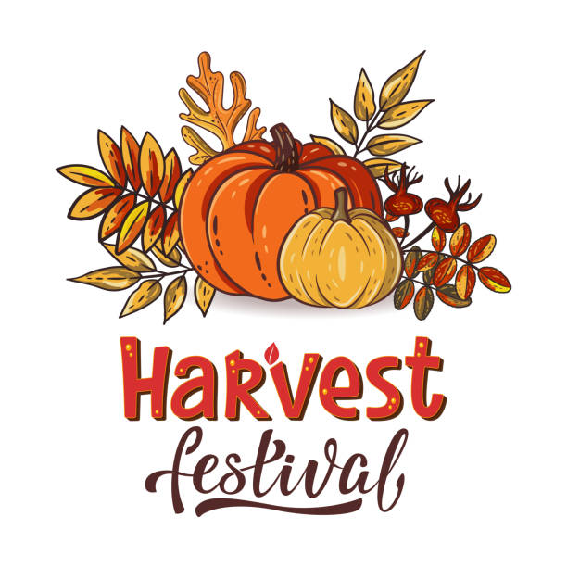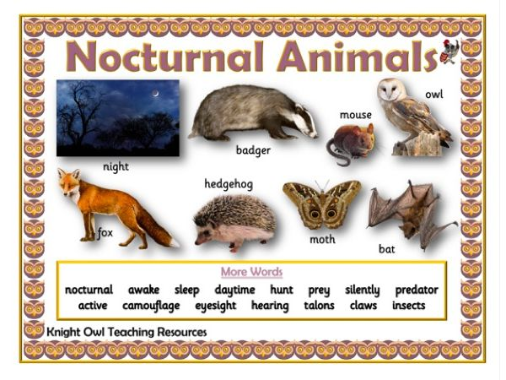
Personal, social and Emotional Development:
We will encourage the children:
To become familiar with the daily routines and expectations at school.
To feel comfortable in the space and get to know the adults and other children in Rainbow.
We will give them every opportunity to explore all learning areas and make the class as their own.

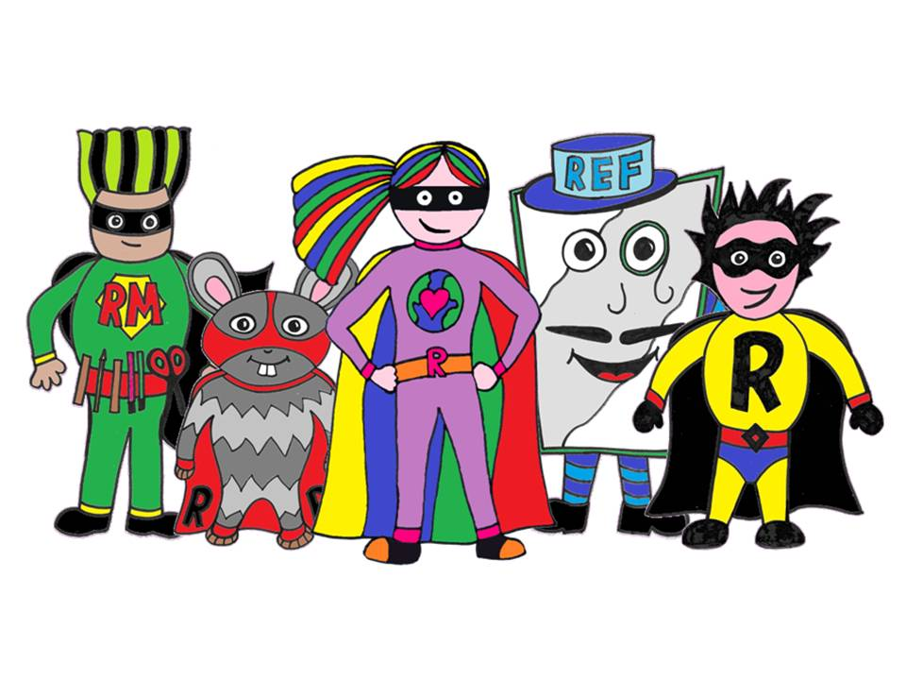

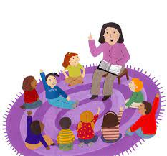
Communication and Language:
We will encourage the children to show us who they are, what their interests are, share their ideas and practise their listening skills by being together sharing stories, rhymes and sing songs.
Physical Development:
We will give the children every opportunity to explore the outside areas and becoming more confident joining in with physical activities.
( core strengthening, balancing, gross and fine motor skills)
The children will visit the Safari zone daily and be out on our Rainbow playground.

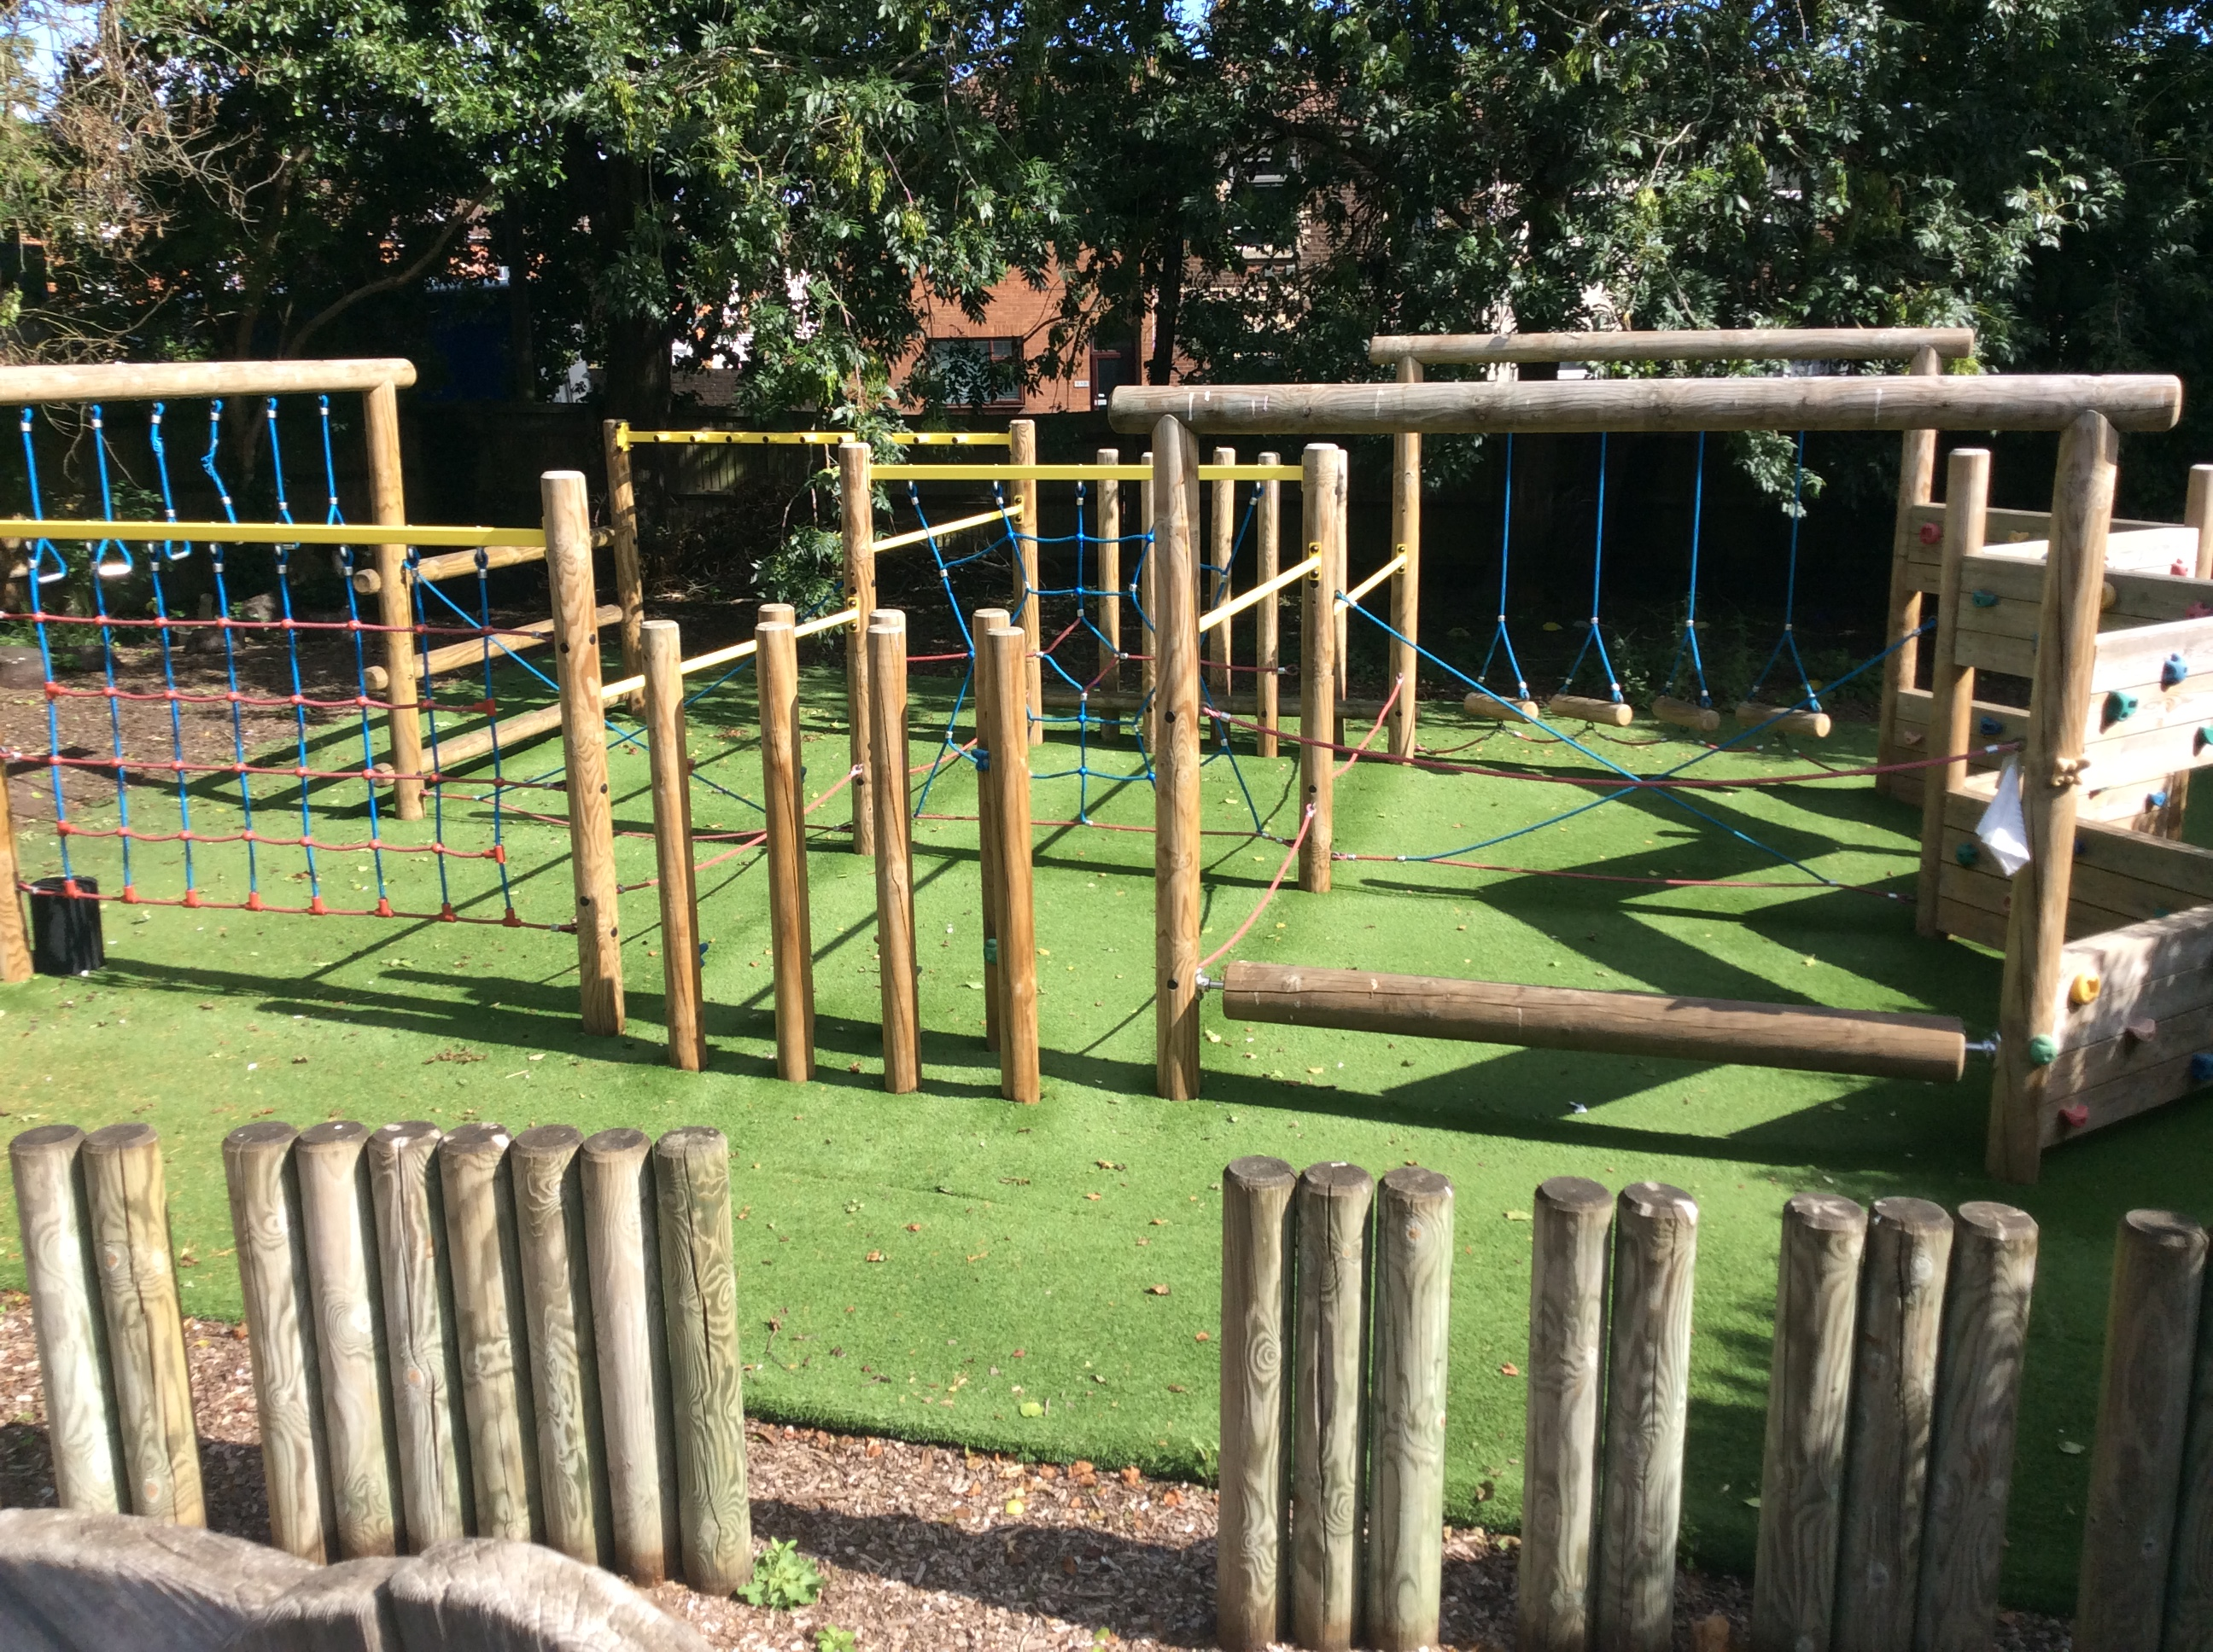

Mathematics:
The children will explore the Maths corner and practise their subitising skills. They will be encouraged to use positional language, compare objects and have a go at putting things in the right order.
Understanding the world:
The children will become familiar with the school grounds, the school building and the local area they live in.
We will look at our surroundings and how they change during the Autumn season.
The children will celebrate Harvest and explore healthy eating.
We will learn about nocturnal animals.

Literacy:
We will be reading lots of stories together, share ideas about the pictures, understand the meaning of text and will start to explore our name letters.
The children will start their Phonics programme “Bug Club” and learn the phase 2 letter sounds.

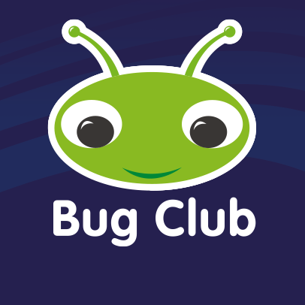

Expressive arts and design:
The children will join in with nursery rhymes and sing a variety of songs linked to our topics.
They will explore loud and quiet sounds and use their body as an instrument.
We will create lots of opportunities for the children to use the art area for junk modelling, painting and all sorts of other crafts.
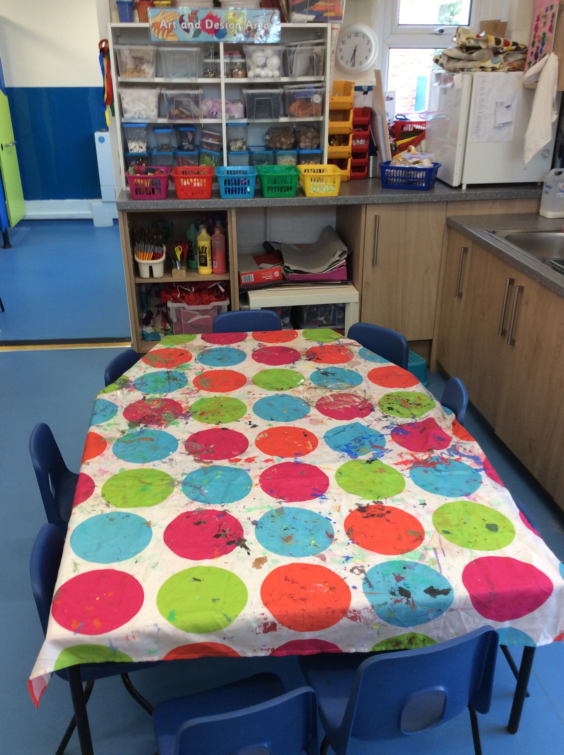
Check list to take to school:
PE shorts + bag
Book bag
Water bottle

And a big smile!

Important dates:
Wednesday 14/9/23- Autumn born: fulltime 8:35 – 3:10
Summer born: part time 8:35-12:10 (13:10)
Monday 26/9/23 – all children in full time
Don’t forget to sign up for Class dojo and check it regularly!

Miss Nelis & the Rainbow Team.

