What’s happening in Year 3 this half term?
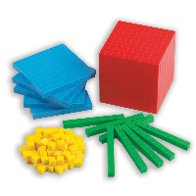  Maths | We will begin this half-term learning about fractions. We will be learning to understand what a fraction is and what the terms numerator and denominator mean. The children will apply their knowledge of multiplication to help them understand what a fraction is. As is the same with every half term, we ask that the children continue to practice and consolidate their knowledge of their times tables.
SPaG   | In SPaG this half term, children will we will be looking at adding prefixes, such as –un, -in. In addition, we will be recapping suffixes (-ed, -est and -er.), We will also be focusing on punctuation such as capital letters, full stops, commas and exclamation marks as well as conjunctions and prepositions. We will also be continuing to practice and learn the Year 3 and 4 common exception words.  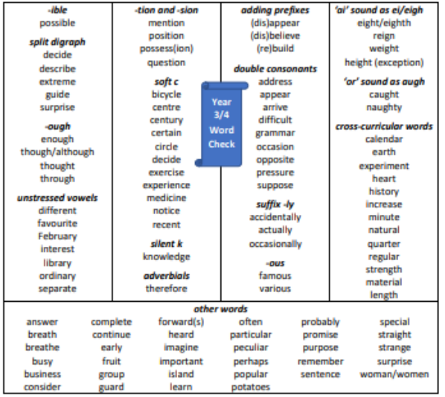  Please encourage your child to practise these at home.
English  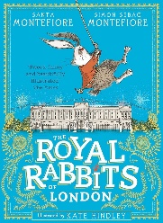 | This half term, we are writing to inform. Our focus text will be ‘The Royal Rabbits of London’. The children will be creating two written outcomes that will be a fact file on Rabbits and a diary entry based on a character from the book.  We are focusing on the use of subheadings and paragraphs and also working on our use of past tense.
Science  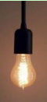 | Our focus for Science this half term will be plants (biology). We will be understanding the importance of each part of the plant as well as the roles they play within the plant’s life. The children will be working scientifically to gather observations and make conclusions from their findings.
PSHE  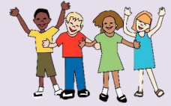 | This half term, we are continuing with our focus on what keeps us safe. We will look at what keeps us safe inside and outside of school with a focus on hygiene, changes to our body and people to keep us safe. We will be recognising respectful behaviour and identifying what this behaviour looks like – this links perfectly to our learning powers!
Captivating Curriculum  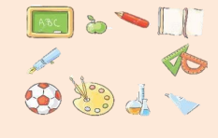 | In Art, we will be learning about sculptures. Our journey will lead us to create our very own sculptures. In RE, we will be looking at symbols within the context of Buddhism. We will also be looking at creating media in Computing, it will include a focus on desktop media and how to edit the layout of text and images. In History, we are learning about the Romans and the Roman Invasion of Britain. In Spanish we are learning about fruits and vegetables.

Additional home learning ideas your child may want to complete
English  Visit a local library with a grown up and find some non-fiction books. You could then find a way to share some of the information you’ve read about e.g. make a poster, model or information fact file. | Art  Look at sculptures around the home and places you go. Anything that the children can explore and discuss how their made, what they represent.
Science  Make an information booklet or poster about plants you have growing in your home or garden. | Computing  Have a go at creating a yes/no questionnaire about anything at home e.g. everyone’s favourite food, sport or book.

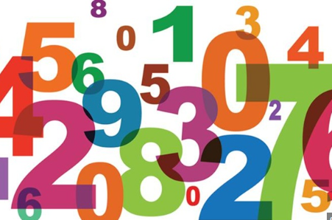
Times Tables

We are now working hard on making sure we are confident with our:

2 x, 3x, 4 x, 5 x, 6x, 8x and 10x tables.
The more you can practice this at home, the easier remembering them will get. You can use Times Tables Rockstars, songs and chants, make your own matching or memory cards or just get someone to ask you lots of times tables questions. How will you be practising yours?

