**Science Activity:** 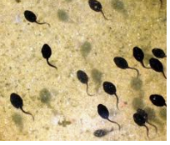

**Several of you have shared videos of your own ‘Tadpole TV’! It is certainly very interesting to watch the tadpoles develop.**

**Could you use this poster to help you describe the life cycle of a tadpole?**

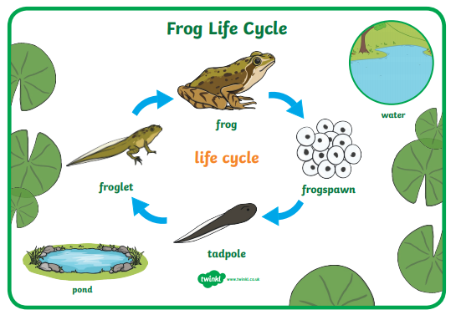

**Could you make a poster of your own?**

* What factors do you think might effect the development / growth of a tadpole?
* What difficulties might they face?
* Can you find out about their predators / any dangers?