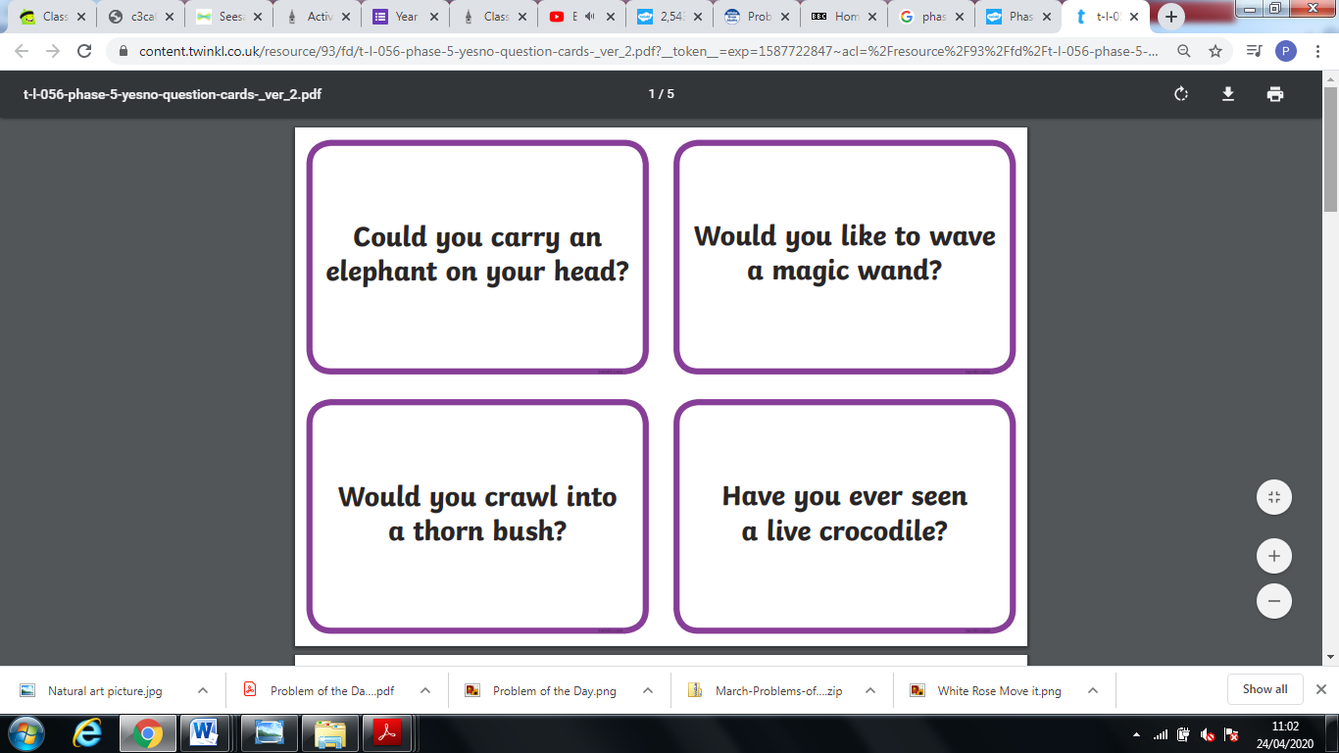

**Yes/No Questions.**

**Read the question and answer with a yes or a no.**

Copy these words out 5 times. Then have a go at writing each word in a sentence.

could

would

should