**Food Tech:**

# Whipple-Scrumptious Fudgemallow Delight

How to make a truly Whipple-Scrumptious sauce for your ice cream sundae.

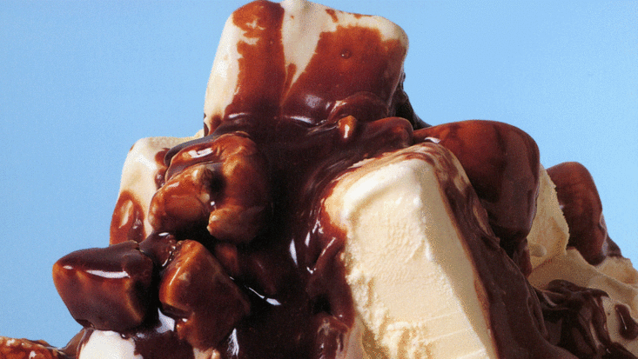

**You will need:**

* **an adult to help you – not to eat.**
* a saucepan
* a large bowl of your favourite ice cream ready in the fridge
* 60g dark chocolate
* 1 Cadbury's Crunchie or similar chocolate bar
* 60g butter
* 80g dark brown sugar
* 150ml double cream
* 8 marsmallows

**What you need to do:**

1. Break the chocolate and the Crunchie into large chunks and set to one side.
2. In a saucepan, over a low heat, melt together the butter, sugar and cream.
3. Stir until all the sugar is dissolved and then turn the heat up and continue stirring for 10 minutes. Be careful, as it gets very hot and can splutter. Use a very long wooden spoon or a tall adult with a long arm.
4. Turn the heat down again, and get your bowl of ice-cream from the fridge.
5. Put the marshmallows, chocolate and Crunchie into the saucepan, stir around once and pour over your ice-cream.

* Don’t forget to wash your hands before you start!

*Do any of these ingredients change state?

* What do you predict will happen to the marshmallows in the hot sauce?

* What happens to the sauce as it cools? Can you reverse this change? How?