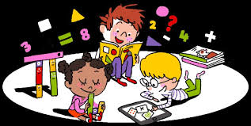

Home Learning

Imagine someone from the future is learning about school in the year 2020. What a surprise they would get!

* What could you tell them about why you are learning at home?
* What is great about learning at home?
* What is tricky about learning at home?
* Is there anything else you would say?
* Ask people at home for any extra ideas that they might have.

Complete the plan.

Write a letter to someone in the future with your ideas.

|  |
| --- |
| Why are you learning at home?  *Dear Future,*  *In March 2020, our schools closed because* |
| What is great about learning at home? |
| What is tricky about learning at home? |
| Is there anything else you would say? |