Lesson One – Read the text and underline the adverbs (words that tell you how or when someone does something.)

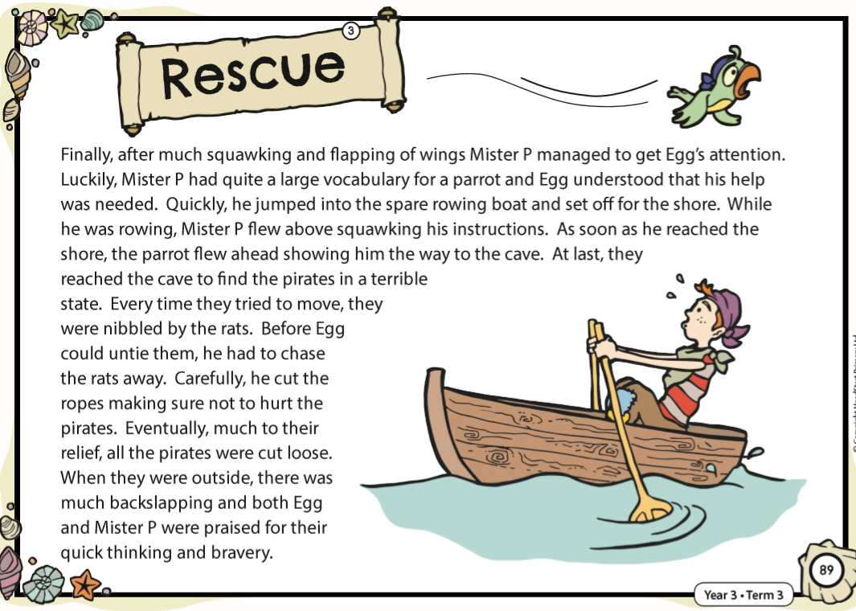

Grammar Lesson One - Activity

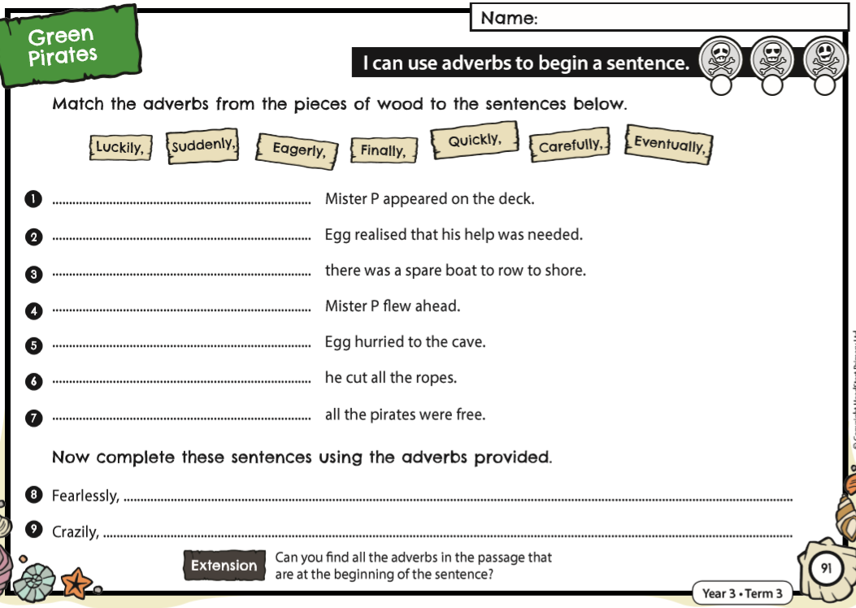

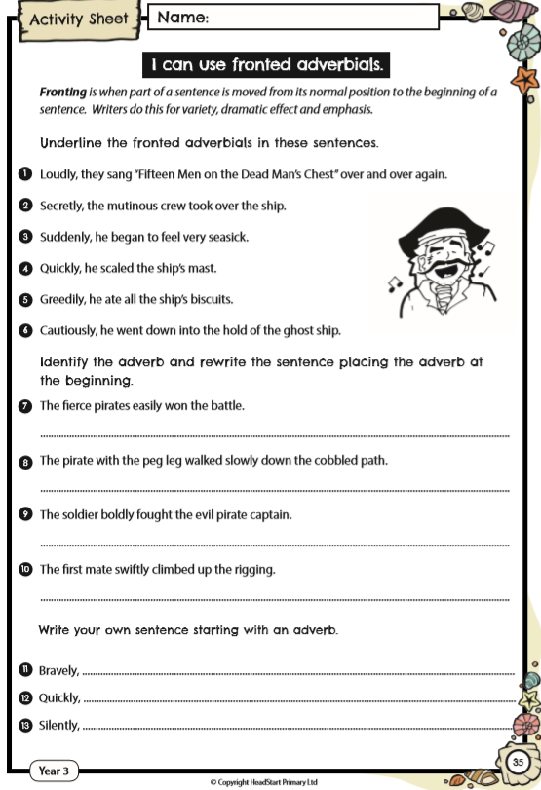Grammar - Lesson Two