**Weekly Writing Challenge**

This week our writing challenge will be to write an exciting narrative story. The idea for your story is ‘Living With Dinosaurs’. In this world, dinosaurs are alive and living with us in modern times. How did this happen? How were they brought back to life? Who discovered them in the firest place?

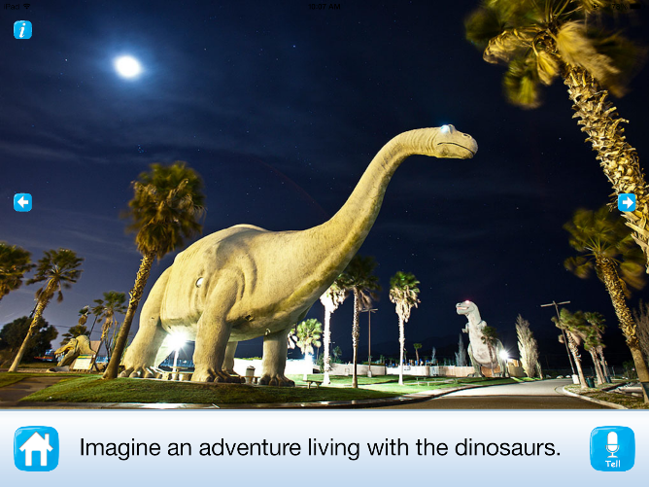

**Think about the following:**

• Who are your characters?

• Where is your story set?

• What is the problem or complication and how will it be

solved?

• How will your story end?

**Remember to:**

• Plan your story with a beginning, middle and end. How are you going to hook the reader at the start? You could write down notes, draw a picture or create a storyboard.

• Organise your ideas into paragraphs.

• Choose your words carefully to entertain the reader.

• Write in sentences. Think about some of the things we have used in class like inverted commas or fronted adverbials.

• Pay attention to your spelling and punctuation.

• Read, check and edit your work carefully.

• Decide how you are going to publish your story: writing it out, typing it, making a book?