Year 4 Home Learning

If you are using this booklet it must mean that we are all having to work from home!



Whilst we are not expecting you to replicate school at home, it will be important that we all try to do some work each school day to keep our skills up.

As your teachers, we think each school day, you should:

* Practise your times tables in whatever way you choose for at least 15 minutes.
* Practise your spellings list.
* Read for at least 30 minutes. This could be a story book or a non-fiction book, or a newspaper / magazine like The Week Junior.
* Spend at least 45 minutes on a focused task. You will be able to come up with good ideas of activities by thinking about the types of learning we already do in school. There are also some ideas in this booklet.

Ms. Bandey & Mrs. Andrews

Maths:

Focus on practising your times tables. You could also use Sumdog and try the White Rose Problem of the Day <https://whiterosemaths.com/resources/classroom-resources/problems/>.

Write your TTRS & Sumdog log-ons here:

You could also look at

<https://www.topmarks.co.uk/maths-games/7-11-years/times-tables>

<https://www.timestables.co.uk/multiplication-tables-check/>

<http://www.primaryhomeworkhelp.co.uk/maths/timestable/index.html>

Science:

Choose a scientist from history whose work has had an impact on the way we live today.

Find out all about them and their invention.

Think about how you can present your findings e.g. poster, information booklet, PowerPoint, explanation text.

Think of an issue today that science could solve.

What is the problem?   
How do you think Science could solve it?

How would our lives change as a result?

Plan your own scientific experiment. You could use of the experiments we’ve already tried at school.

Set up your experiment and record the results. What did you find out? Was it a fair test?

Write a persuasive argument about the invention or scientific discovery you believe to have been the most important for humankind.

History & Geography:

Choose an aspect of Roman life to find out more about.

How will you present your findings?

Make a poster to explain the water cycle.

Watch an episode of Horrible Histories and make a poster or write down what you have found out.

Be creative!

Use what you have at home to make something Roman!

Put all the History learning you have done at St Denys on a timeline. Present it as creatively as you can.

Spanish:

If you have internet access, you could try expanding your vocabulary by using duolingo.com

Teach someone at home the Spanish you have learnt at school.

Try to greet each other in Spanish, count together or name some stationery supplies.

Power of Reading (English):

Choose a fiction book (chapter book) that will provide you with a reasonable level of challenge (just like Charlotte’s Web).

Create some activities around the book, just like the things we have done with Charlotte’s Web.

E.g.

Read some of your story aloud to someone else at home.

Write a newspaper report about a key event in the story.

Remember your headline, captions and to include reported speech.

Write a diary entry in role as one of the main characters.

You could write more than one from different characters’ points of view or to show how your character’s feelings change throughout the book.

Design a new front cover for your story, including a ‘blurb’ which outlines the story.

Search the book for examples of the grammar we have been learning this year e.g.

* Fronted adverbials
* Subordinate clauses
* Homophones
* Possessive apostrophes
* Correctly punctuated speech
* Conjunctions

Predict what you think will happen next in the story.

You could write the next chapter.

Compare your predictions to what actually happens.

List interesting vocabulary from the book, making sure you know what they mean. Can you write them in to your own sentences?

Create a production of the story! You could use puppets, your cuddly toys or willing siblings!

You could make a programme for your performance, or write the script.

Community

Do you have family, friends or neighbours who you can’t see for a while?

Why not write them a letter or card to cheer them up?

Why not work towards a Blue Peter badge? You can earn them for lots of different things.

https://www.bbc.co.uk/cbbc/joinin/about-blue-peter-badges

Additional resources:

Additional Resources:

Toy Theater

https://toytheater.com/

Educational online games

DK Find Out

https://www.dkfindout.com/uk/…

Activities and quizzes

Twinkl

https://www.twinkl.co.uk

This is more for printouts, and usually at a fee, but they are offering a month of free access to parents in the event of school closures.

Geography Games

https://world-geography-games.com/world.html

Geography gaming!

The Artful Parent

https://www.facebook.com/artfulparent/

Good, free art activities

Oxford Owl for Home

https://www.oxfordowl.co.uk/for-home/

Lots of free resources for Primary age

Nature Detectives

https://naturedetectives.woodlandtrust.org.uk/naturedetect…/

A lot of these can be done in a garden, or if you can get to a remote forest location!

Tinkercad

https://www.tinkercad.com

All kinds of making.

Prodigy Maths

https://www.prodigygame.com

Is in U.S. grades, but good for UK Primary age.

The Kids Should See This

https://thekidshouldseethis.com

Wide range of cool educational videos

Blockly

https://blockly.games

Learn computer programming skills - fun and free.

Scratch

https://scratch.mit.edu/explore/projects/games/

Creative computer programming

National Geographic Kids

https://www.natgeokids.com/uk/

Activities and quizzes for younger kids.

Duolingo

https://www.duolingo.com

Learn languages for free. Web or app.

Mystery Science

https://mysteryscience.com

Free science lessons

BBC Learning

http://www.bbc.co.uk/learning/coursesearch/

This site is old and no longer updated and yet there's so much still available, from language learning to BBC Bitesize for revision. No TV licence required except for content on BBC iPlayer.

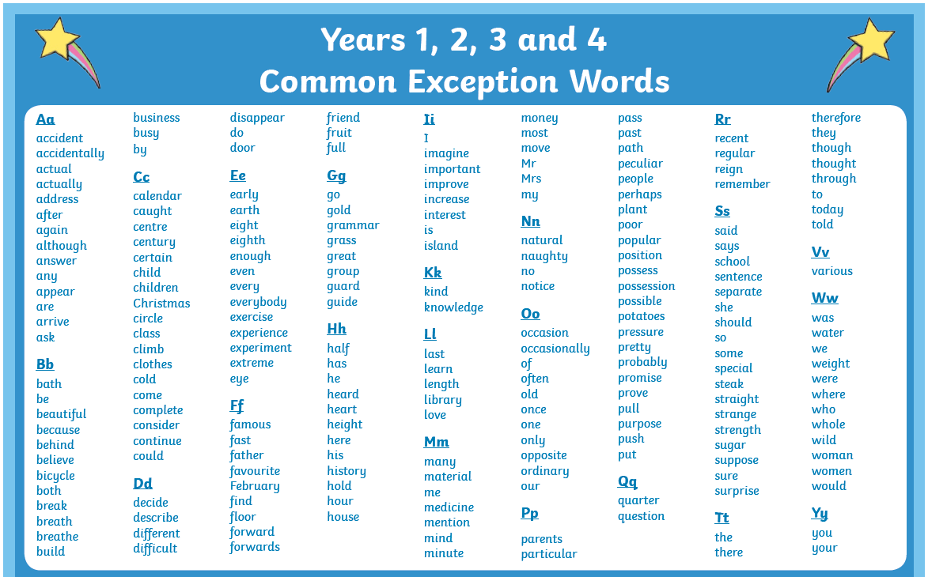7777

