**St Denys Primary School**

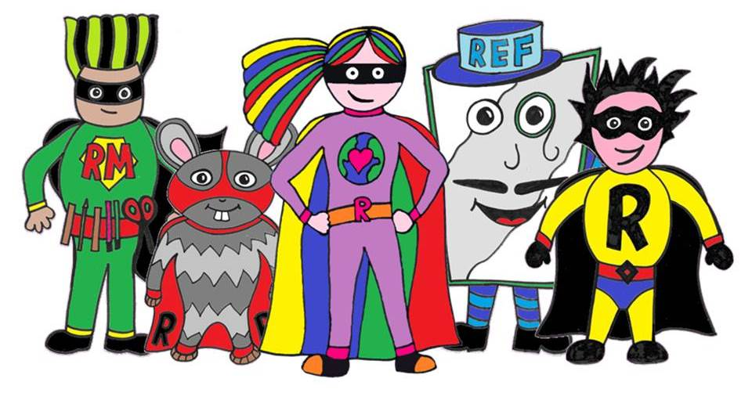

Y4 Home Learning

**Summer (1) 2020**

**Week 1**

**Creativity, Choice, Challenge**

**Achievement for All**

**Welcome back Class-4-tastic!**

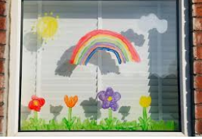

A big smiley hello from your teachers!

We hope that this finds you all safe and well. We are looking forward to getting back in touch with you all this week and hearing from you via Class Dojo. We are sure you will have lots to share with us.

As school is still closed for most of us, you will need please to carry on with the fantastic job you have already been doing of learning at home. This new booklet should help you with activities and ideas for learning *this first week* of the new term.

This week we have themed our learning around…drum roll…the natural world with some help from Steve Backshall, some friendly (ish) wolves, mini beasts and some particularly tricky to spell… 2D shapes.

We have given you 5 each of English, Maths and Spelling activities, along with some Topic ideas. You could choose to do one of each, each school day, or to focus on one area of learning per day – you and your families will be able to work out the best approach for you.

Whilst we are not expecting you to replicate school at home, it will be important that we all try to do some work each school day to keep our skills up.

As your teachers, we think each school day, you should:

• Practise your times tables in whatever way you choose for at least 15 minutes.

• Practise your spellings in whatever way you choose for at least 15 minutes.

• Read for at least 30 minutes. This could be a story book or a non-fiction book, or a newspaper / magazine like The Week Junior.

• Spend at least 45 minutes on a focused English / Maths task.

* There are also some TOPIC ideas in this booklet that you could try out as independent work. These topic activities could even be done with a brother or sister (we’re sure Ron Reciprocity would help out too). Or, you may have an area of interest/ project you would like to investigate and organise yourself.

We hope that you enjoy the activities we have prepared for you. Try your best (CX%) and remember we are here if you need help.

We look forward to hearing from you via Class Dojo on our usual days.

**Ms. Bandey & Mrs. Andrews**

|  |
| --- |
| **St Denys Primary School Y4 English Home Learning Tasks** |

|  |  |
| --- | --- |
| Activity 1:  **Learn about wolves with Steve Backshall!**   * **Watch this video clip with Steve Backshall to learn about Grey Wolves!**   <https://www.youtube.com/watch?v=pi3KPf1LuLM>  Once you have watched the video see if you can make some notes/jottings of 3-5 facts that you remember from the video.   * Now watch the video clip again but this time listen out carefully for the answers to these questions:   1.How much more powerful is a wolf bite than a German Shepherd police-dog?  2. How much more powerful is a wolf’s sense of smell than ours?  3. How far way can wolves hear another’s howl? | |
|  |  |
| Activity 2:  **Challenge yourself with a**  **reading comprehension all about wolves. (Find it at the end of the booklet.)** | Activity 3:  **Create a wolf fact file! (More information about this at the end of the booklet.)** |
| Activity 4:  **Make your own visual glossary to explain some technical wolf vocabulary.**  During these activities you will have read some new and interesting technical vocabulary. Can you make a picture glossary to explain some wolf words?  **Words you could use = scent, howl, territory, off-spring, communicate** OR read back through the wolf reports to find your own.  E.g. off-spring = Off-spring is the term used to describe an animal’s young (or a person’s child).THEN add your illustration to explain. | Activity 5:  **Can you rehearse and perform a poem about a mysterious (wolfy) visitor to the park?**  **(Find the poem at the end of the booklet.)** |

|  |
| --- |
| **St Denys Primary School Y4 Spelling Home Learning Tasks** |

Week 1 Spellings

Session 1: Choose your spelling level for this week, or which spellings you are going to ‘mix and match’ (be honest about which one will be the right challenge for you – ideally you want to be learning about 5-8 new spellings this week). Get someone to test you on the whole list and work out which ones from the list you will really need to focus on (remember to aim to learn about 5 - 8).

Session 2: Complete Look, Cover, Write, Check for your focus spellings (5-8 words you chose yesterday).

Session 3: Write your focus spelling words in sentences to show you understand what they mean.

Session 4: Use Pyramids (adding one letter at a time to your word) or Rainbow Writing (write each spelling in at least 5 different colours) to practice your focus spellings.

Session 5: Test! Ask someone to test you on your spelling words. How many did you learn this week?

Level 3

Suitable

Capable

Credible

Eligible

Hospitable

Programme

Occasionally

Environment

Photograph

Principle

Presence

Optimistic

Phenomenon

Professional

Independent

Level 2

Library

Thought

Beautiful

Grateful

Greatest

Faintest

Gorgeous

Enormous

Height

Weight

Probably

Possible

Century

Circuit

Centre

Level 1

Stone

Alone

Moan

Foam

Grown

Town

Bold

Told

Folded

Could

Would

Small

Waterfall

Basketball

Football

|  |
| --- |
| **St Denys Primary School Y4 Maths Home Learning Tasks** |

|  |  |  |
| --- | --- | --- |
| Activity 1:  Draw as many different **2D shapes** as you can think of. How many can you name? Label them.  Find out the names for any you aren’t sure of.  (The glossary at the end might help you) | Activity 2:  Create your own **2D shape animal** – an animal drawn using 2D shapes.  How many different shapes can you use?  Label each of the shapes you have used. | Activity 3:  Explain what the words **parallel** and **perpendicular** mean (the glossary at the back can help).  Draw a picture of a house, using lots of straight lines. Colour all the sets of parallel lines red, and all the perpendicular lines blue. |
| Activity 4:    What is a quadrilateral?    Activity 5: | | |

Glossary

**Right angle** – an angle of 90°, for example the corner of a piece of paper

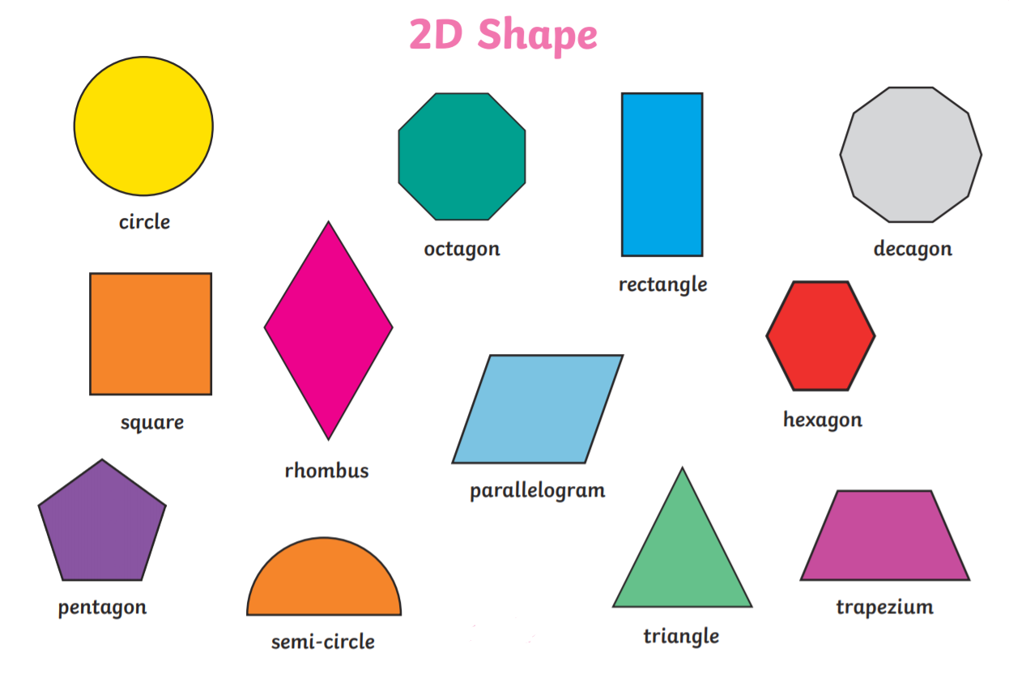

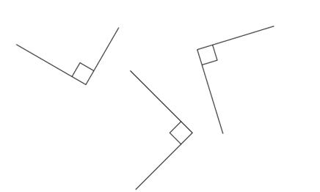

**Perpendicular lines** – straight lines that meet or cross at a right angle



**Parallel lines** – straight lines that always remain the same distance apart

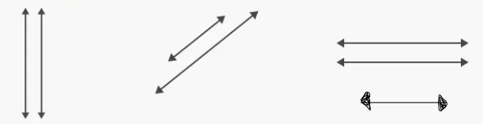

|  |  |
| --- | --- |
| **St Denys Primary School Y4 Topic Home Learning Tasks** | |
| Either draw or print an image of a minibeast and label its body parts. Make sure you research what each part of its body is/does. | |
| What signs of new life can you see?  Complete a detailed sketch of some blossom, a flower or unfurling new leaves. | |
| Create an information leaflet about an animal of your choice.  Include awesome facts about the animal, its habitat, where it comes from, the food it eats etc. | Google how to make a bug hotel. See if you can create a space outside using some rocks/ sticks/ fir cones etc that would create a habitat for minibeasts. Who will be your first guest? |
| Complete a wildlife survey  Record the different wildlife you see by looking out of a window or door for a set period of time.  Can you identify each different creature (including different types of birds)?  How will you present your findings – in a table, a graph, a pictogram? | |

# Look, Say, Cover, Write and Check!

Tick the columns as you follow the instructions from left to right. Make sure you spell the words in the ‘write’ column. If you spell the word incorrectly, write it again in the correction column.

|  |  |  |  |  |  |  |
| --- | --- | --- | --- | --- | --- | --- |
|  | look | say | cover | write | check | correction |
|  |  |  |  |  |  |  |
|  |  |  |  |  |  |  |
|  |  |  |  |  |  |  |
|  |  |  |  |  |  |  |
|  |  |  |  |  |  |  |
|  |  |  |  |  |  |  |

# Look, Say, Cover, Write and Check!

Tick the columns as you follow the instructions from left to right. Make sure you spell the words in the ‘write’ column. If you spell the word incorrectly, write it again in the correction column.

|  |  |  |  |  |  |  |
| --- | --- | --- | --- | --- | --- | --- |
|  | look | say | cover | write | check | correction |
|  |  |  |  |  |  |  |
|  |  |  |  |  |  |  |
|  |  |  |  |  |  |  |
|  |  |  |  |  |  |  |
|  |  |  |  |  |  |  |
|  |  |  |  |  |  |  |

**English Activity 2: Wolf reading comprehension activity**

**You will need a grown up to help you read and/or check your answers with this activity.**

* Decide which Wolf Report is the right level of challenge for you. Wolf Report 1 is a good level of challenge for Yr4, Wolf Report 2 is even more challenging!
* Now, carefully read the report and take your time to answer the questions.
* Remember to skim and scan the text, you may want to use a pen to highlight information.
* How will your record your answers? Using beautiful handwriting and appropriate punctuation of course! However, after you may also decide to use a voice recorder on a phone or maybe video yourself presenting the answers on your own wildlife programme…you decide.

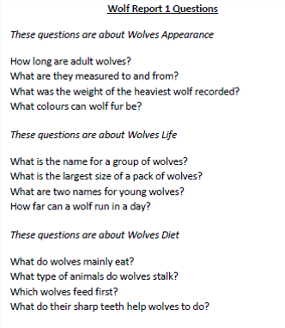

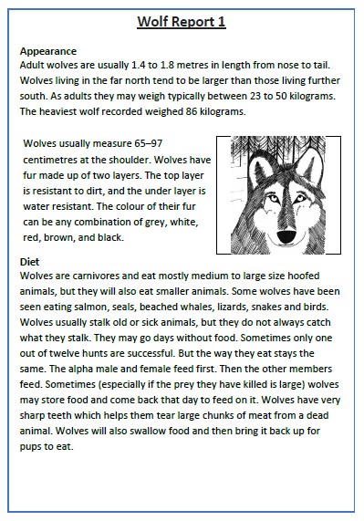

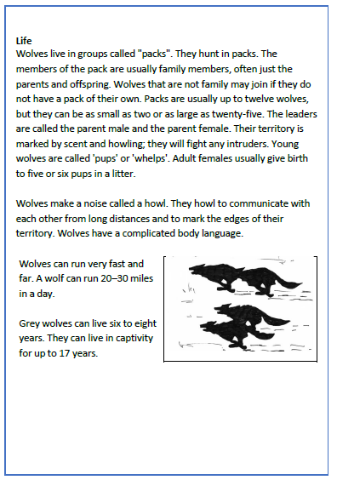

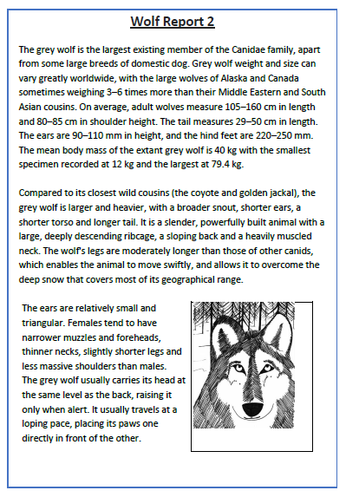

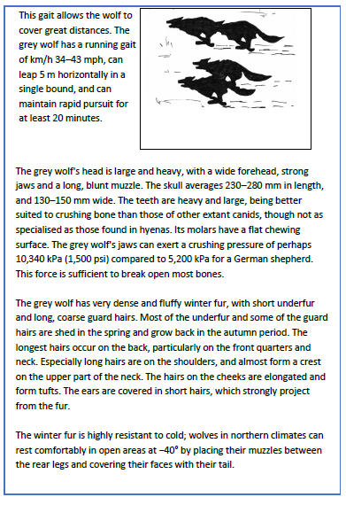

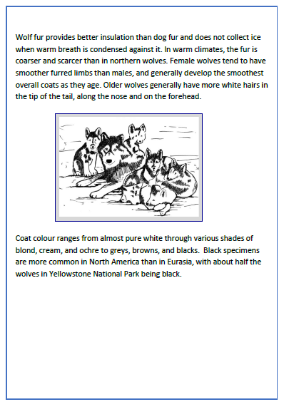

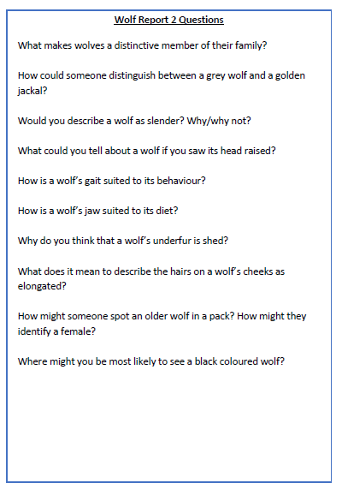

**English Activity 3: Creating a WOLF Factfile !**

**Independent**

* You now know quite a lot about wolves, especially grey ones!
* Cut out this picture of a grey wolf and stick it onto a new piece of A4/ into your work book/ onto a fancy piece of larger paper you may have at home.
* Use information given to you in the previous activities to write some facts about wolves to make your own wolf FACT FILE.
* It’s up to you how you set your work out. You may want to use some sub-headings to organise facts into paragraphs or make it more like a poster with your facts in boxes…you decide…just make sure it is eye-catching!
* 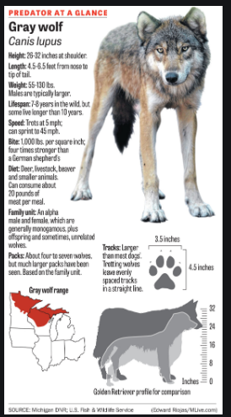 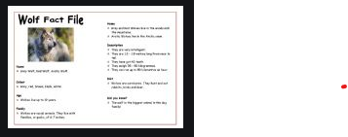

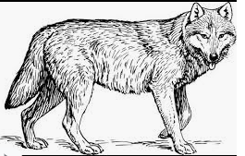

**Activity 5 Reading and performing a Wolf Poem!**

**Independent**

* Read this super eerie poem written by Richard Edwards.

Try rehearsing it by reading it aloud. Put plenty of expression in! It’s really rather a creepy poem full of clues and questions to make us wonder if there really is a wolf in the park. How will you use your voice to create tension? Will you read loudly or quietly? Can you pause at the commas? What about the ‘…’?

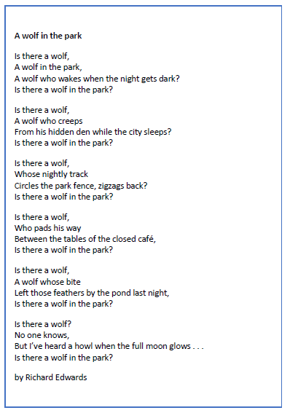

Maybe you could write and add your own verses…let’s hope there are no wolves in Riverside park though…

Could you perform it to your family at home? - did you spook them? Maybe you could perform it as a video call to someone in your wider family? We’d love to see any videos on Class Dojo!

