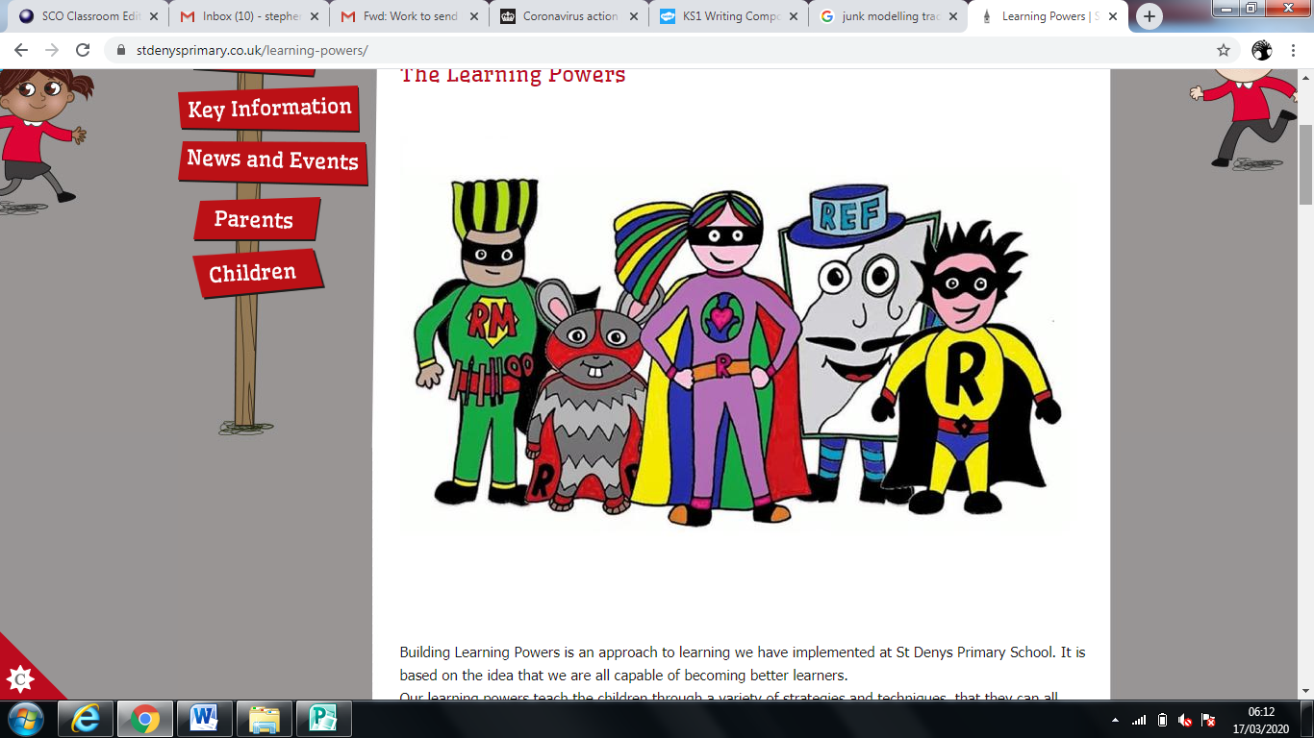

Working at home nr 2

Rainbow Class

St Denys Primary School

Dear Rainbow Class,

Here is your second “Home Learning booklet”.

You will see that most of the learning is similar but the activities will be slightly different from the first booklet.

For **Phonics**, **English** and **Maths**, there are everyday activities. You can choose to do them from the booklet or to visit the School-closure-page-Rainbow and find new learning on there to supporting **Phonics**, **English** and **Maths**, every day.

As a minimum, we would like the children to do these activities every school day whilst at home.

In addition, there are some other activities included. Children could choose one of these tasks each school day and spend up to 40 minutes exploring them.

Don’t forget to plan in some Plan-Do-Review time ☺

**Have fun!**

From **the Rainbow team**

**PS:** if there are any questions or you want to show us your work then you can find us on Class Dojo!

**Phonics**

Every day activities

* Read for at least 10 minutes every day. Practise blending sounds and talking about what is happening in the book.
* Practise phonics phase 2/3 sounds , Tricky words and read sentences.

Focus activities

|  |  |
| --- | --- |
| Go over the letter sounds on your sound mat and see if you know all the actions.  Can you make words putting some letter sounds together.  ch-o-p sh-i-p b-oo-k l-igh-t | Go over the High F words.  Start with Phase 2 and phase 3 if that is easy have a go at Phase 4.    ( on school-closure-page-rainbow) |
| Interactive Phonics games  Go to Phonicsplay,com  Login: march20  Passw: home  Choose your own Phase 2 / 3 / 4 | Look at lots of different types of books and share/talk about what you spotted in the books.  ( information books/ picture books, Phonics books) |
| Choose a picture from your favourite book. Talk about what you can see in the picture.  ( what, where, who, when, why ) | Practise blending by reading the phase 2/3 power points.  ( on school-closure-page-rainbow) |

**English**

Every day activities

* Practise writing a sentence , thinking about the sentence structure. ( capital letter, finger spaces, full stop )
* Practise the cursive handwriting by going over the letter sheet.

Focus activities

|  |  |
| --- | --- |
| Choose your favourite animal and make an information booklet about this animal.  Where does it live?  What does it look like?  What does it eat?  How does it survive? | Build a Town and draw up a map and write down the information,  You can use symbols and then label them or explain the history of the town…… |
| Can you write me an adventure with a beginning, middle and end?  The cat went shopping.  It took the wrong path and got lost in the forest.  A dragon saw the cat and wanted to eat it……. | “Sentence Doctor”  Look at the sentence and make it better! Are the full stop, capital letters and finger spaces in the right place?  ( on school-closure-page-rainbow) |
| Write a list of things you:  love to do, to eat, to play, to make or write your own time table of the day. | Write silly sentences!  The Hippo jumped into the birthday cake!  ( on school-closure-page-rainbow) |

**Maths**

Every day activities

* Practise making all the different ways of a number, using a part-part-whole template. ( see sheet attached )
* Practise number bonds up to 10.

( 1+9, 2+8, 3+7, 4+6, 5+5, 6+4, 7+3, 8+2, 9+1 )

* Practise counting in 2’s 5’s and 10’s.

Focus activities

|  |  |
| --- | --- |
| Counting jobs:  Make a list of something you want to count and write it down, using a tally chart or write the number.  ( how many pots and pans, books, cuddly toys, pens ect | Roll a dice and write the number down. Roll it again to get another number. Can you add both of the numbers together? Can you write it as a number sentence? Can you roll it 3 times and add the numbers together? |
| Create a shape picture. Look for small objects in your house that are 2d shapes – eg circles, squares etc.  Use these to draw around to create your very own shape picture. | Go to the Cbeebies website and have a go at:  “add up with the Numberblocks”  (Lots of different maths activities  on school-closure-page-rainbow) |
| Numberblocks jobs:  Make a Wonderful world of … sheet and put all the info of that number on.  ( write / make 4, square, 4 things, ) | Set up your own little play shop at home. Eg, with toys. Write tags to display how much each item costs. Ask your grown up to ‘buy’ some things from your shop. How much do all the items cost? |

**Other ideas**

|  |  |
| --- | --- |
| Can you come up with a building idea, draw the structure and try and build it!  ( racing track, bridge, tower, castle, vehicle, | Can you keep a Spring diary?  What is happing to the trees and plants outside?  What is the weather like?  Maybe you can grow something? |
| Can you create a piece of artwork? Perhaps a collage, a painting, a model or a drawing of your favourite things? | Create a landscape  Using natural objects from your garden or craft materials.  ( forest, mountains, dessert, meadow, cliffs, magical land..) |
| Make your own Puppet Show  Come up with a story and characters.  Use lolly sticks cut out your own characters, use a cereal box as the stage or use your own toys to act out a story! | Set up a treasure hunt.  Hide something in your house and write out a treasure hunt, with arrows, cards with clues or draw a map to follow……. |
| Play board games or make puzzles!  Children can practise counting, number recognition, moving forward, backwards, taking turns | |