St Denys Primary School

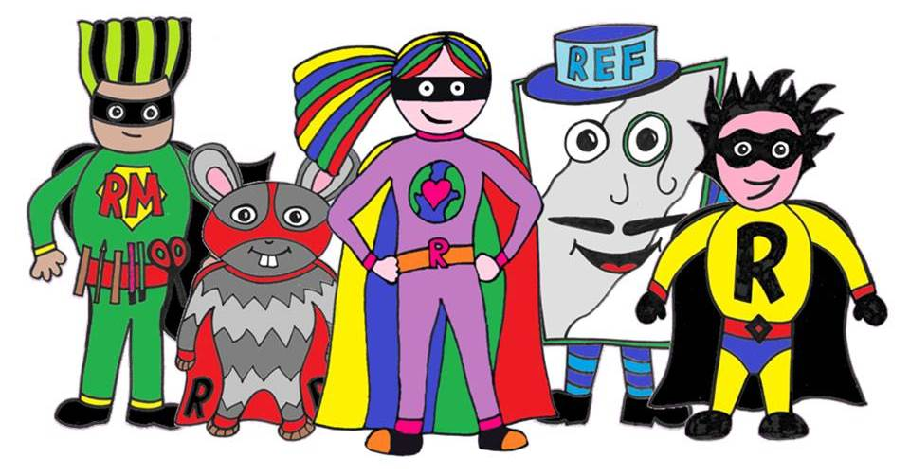

Rainbow
Home Learning
Week Beginning 1st June
Creativity, Choice, Challenge
Achievement for All

Dear Rainbow Class,
Here is your “Home Learning booklet” 01/06/06
You will see that most of the learning is similar but the activities will be slightly different from the first booklet.

For Phonics, English and Maths, there are everyday activities. You can choose to do them from the booklet or to visit the School-closure-page-Rainbow and find new learning on there to supporting Phonics, English and Maths, every day.
As a minimum, we would like the children to do these activities every school day whilst at home.

In addition, there are some other activities included. Children could choose one of these tasks each school day and spend up to 40 minutes exploring them.
Don’t forget to plan in some Plan-Do-Review time
Have fun!
From the Rainbow team

PS: if there are any questions or you want to show us your work then you can find us on Class Dojo!

Phonics

Every day activities
- Read for at least 10 minutes every day. Practise blending sounds and talking about what is happening in the book.

- Practise phonics phase 2/3 sounds , Tricky words and read sentences.

Focus activities

Go over the letter sounds on your sound mat and see if you know all the actions.  Can you make words putting some letter sounds together.  ch-o-p sh-i-p b-oo-k l-igh-t | Go over the High F words.  Start with Phase 2 and phase 3 if that is easy have a go at Phase 4.  ( on school-closure-page-rainbow)
Interactive Phonics games  Go to Phonicsplay,com  Login: march20  Passw: home  Choose your own Phase 2 / 3 / 4 | Look at lots of different types of books and share/talk about what you spotted in the books.  ( information books/ picture books, Phonics books)
“ I spy with my little eye”  Choose an I spy sheet and make a list of the things you can see.  Use your phonics sounds to write them out. | Practise blending by reading the phase 2/3 power points.  ( on school-closure-page-rainbow)

English

Every day activities
- Practise writing a sentence, thinking about the sentence structure.
( capital letter, finger spaces, full stop )

- Practise the cursive handwriting by going over the letter sheet.

Focus activities

Choose one of the farm animals and make an information booklet.  How do you look after it?  What are it special features?  What job does it do on the farm?  What/how about their babies….. | “Oscar and the frog”  Do some of the sentence writing suggestions that are on the class page about “Oscar and the frog”.
“Life Cycles”  Choose one; a frog, a butterfly, a fish, a bird or a cat and write their life cycle down. | “Sentence Doctor”  Look at the poorly sentence and make it better!  Are the full stop, capital letters and finger spaces in the right place?
Write a list of things you:  love to do, to eat, to play, to make or write your own time table of the day. | Write silly sentences!  The Hippo jumped into the birthday cake!

Maths

Every day activities
- Practise making all the different ways of a number, using a part-part-whole template. ( see sheet attached )

- Practise number bonds up to 10.
( 1+9, 2+8, 3+7, 4+6, 5+5, 6+4, 7+3, 8+2, 9+1 )

- Practise counting in 2’s 5’s and 10’s.

Focus activities

Number sentence Challenge  Have a go at the challenge sheet, you can just do 10 sums at a time or like the sheets suggest, time yourself. | Numberbonds to 10/20  Practise all the different ways to make 10 / 20. See if you can remember them …. 2 and 8 are 10!
Create a shape picture. Look for small objects in your house that are 2d shapes – eg circles, squares etc.  Use these to draw around to create your very own shape picture. | Go to the Cbeebies website and watch the next Numberblocks episode.  Press the pause button and see  what can you spot?  (Lots of different maths activities  on Cbeebies)
Practise using a 10 frame  Look at the numbers from 0 to 20 and put them in ten frames. What does the number look like? | 2d / 3d shape corner  Can you make a shape corner in your house? What type of shapes can you find?

Other ideas

Creepy crawlies fact file  Make your own Creepy Crawly information book.  You can draw what you spotted in your booklet and write some facts. | Creepy crawlies Hunt  Have a go at finding / spotting bugs  when you go outside. You can takes photos or write a list of how many you saw.
Build a Farm  Can you create the Farm from the story “what the ladybird heard” with all the different animals.  You can craft it/ draw it/ build it…. | Create a landscape  Using natural objects from your garden or craft materials.  (forest, mountains, dessert, meadow, cliffs, magical land..)
Mr Fielder’s challenge  Can you make your own obstacle course in your front room or garden? Try and put at least 3 physical challenges in it. | Set up a treasure hunt.  Hide something in your house and write out a treasure hunt, with arrows, cards with clues or draw a map to follow…….
Play board games or make puzzles!

Children can practise counting, number recognition, moving forward, backwards, taking turns

Phonics: Phase 3 sounds
Write a list of all the things you can spy.
English: Sentence writing.
The Sentence doctor
 Full stop Words
Finger spaces 
Capital letters Aa Bb Cc

Make sure that every time you write a sentence you think about “the Sentence Doctor”.
Does your sentence start with a capital letter?
Are you using your finger spaces?
Have you written down all the sounds you can hear?
Have you put a full stop at the end of your sentence?
For example:
Frog the . Oscar and
(Oscar and the frog)
Have fun making the sentence better!

Poorly sentences from the story “Oscar and the frog”

1. grow It helpedyou .
2. was I Why hungry? for milk
3. sprout from. Most seeds plants
4. tiny. Poppy seeds plants have
5. hugehave seeds Coconut. palm trees
6. different We all foodneed to grow.
7. stopped growing I have now.
8. plants of eggs? Do hatch out
9. Eachlivingthingtakestheirowntime.
10. seeand Wait!

English: “Oscar and the frog” sentence writing.
Have another look and listen to the story…….
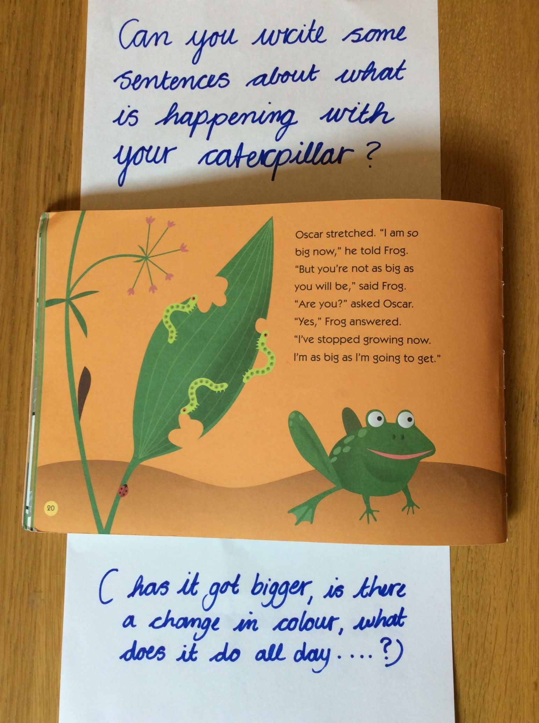

English: “Oscar and the frog” sentence writing.

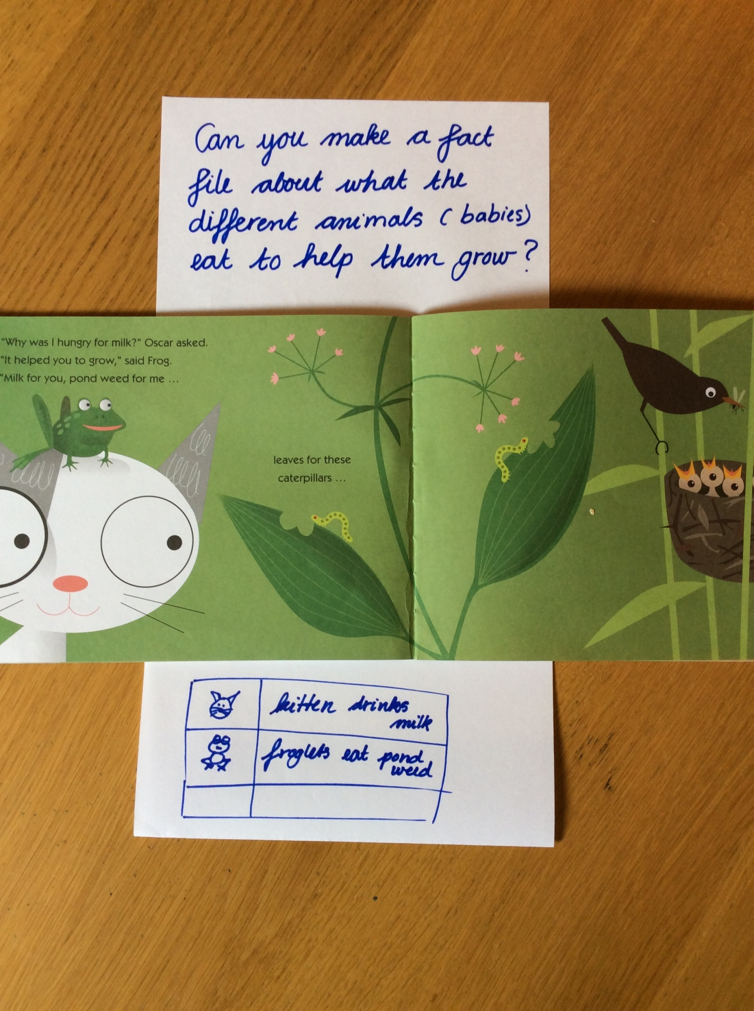
English: “Oscar and the frog” sentence writing.

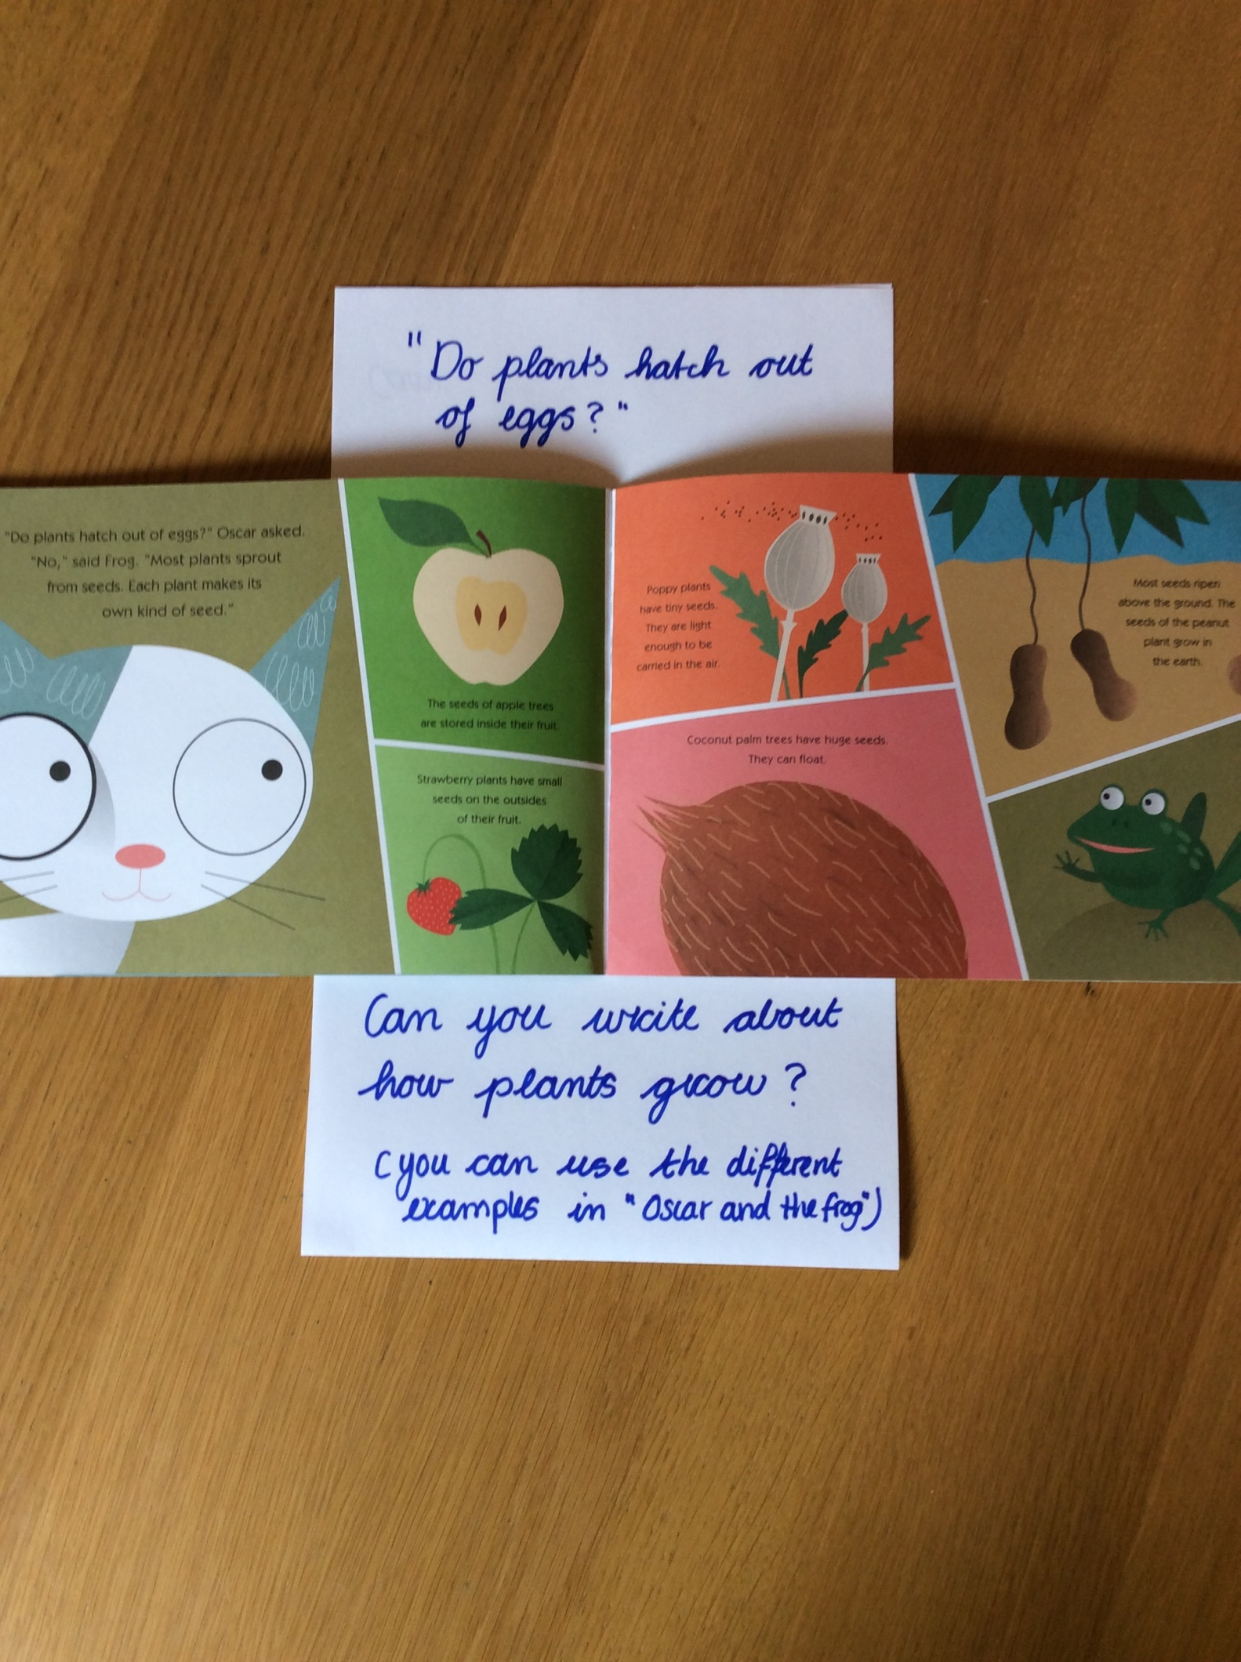

Maths: Number bond challenges

Number Bond Challenge 4:
4 + 6 = | 2 + 18 = |  | 50 + 50 =
1 + 9 = | 70 + 30 = |  | 80 + 20 =
30 + 70 = | 14 + 6 = |  | 2 + 8 =
5 + 15 = | 5 + 5 = |  | 17 + 3 =
80 + 20 = | 17 + 3 = |  | 40 + 60 =
2 + 8 = | 11 + 9 = |  | 100 + 0 =
13 + 7 = | 90 + 10 = |  | 3 + 7 =
10 + 90 = | 6 + 4 = |  | 1 + 9 =
16 + 4 = | 70 + 30 = |  | 60 + 40 =
7 + 13 = | 1 + 9 = |  | 18 + 2 =
10 + 10 = | 14 + 6 = |  | 5 + 15 =
1 + 9 = | 0 + 20 = |  | 10 + 0 =
8 + 2 = |  | 2 + 18 =

Handwriting:

