Year 3 Autumn 1 Curriculum Newsletter

|  |  |
| --- | --- |
| **Maths** | This half term, our maths learning will focus on place value, addition and subtraction. We will look at 3-digit numbers, ordering and comparing numbers; finding 1, 10 and 100 more or less than a given number and developing mental strategies to calculate with large numbers. We will build on our learning from last year about formal column methods of adding and subtracting, extending to using these written methods for 3- digit numbers. **Please encourage your child to practise the 2, 5 and 10 times table.** |
| **SPaG** | In SPaG this half term, we will be looking at adding suffixes beginning with vowel letters to words with more than one syllable and doubling the final constant, such as –ing, -ed, -er and –en. We will be focusing on punctuation such as capital letters, full stops, commas and exclamation marks as well as conjunctions and prepositions. We will also be recapping the Year 2 common exception words. These are tricky because the children can’t always use their phonics to spell them!    **Please encourage your child to practise these at home.** |
| **English** | This half term, we’ll be reading the book ‘How the stars came to be’ by Poonam Mistry. This book is about a world where people and nature live in harmony. It tells the tale of a young girl’s journey to finding light in the dark. The sun teaches her that no matter how dark it may seem, light is on the way. In Guided Reading, we will be reading The Night Gardener by Terry Fan and Eric Fan. Thank you for your continued support with reading at home – it’s been fantastic to see so many children already recording what they have been reading at home in their reading record books. |
| **Science** | Our focus for Science this half term will be Living Animals including Humans. We will identify that animals, including humans, needs the right types and amount of nutrition and we will learn that humans (and some other animals) have skeletons and muscles for support, protection and movement. We will work scientifically by gathering, reporting and presenting information in different ways. |
| **PSHE** | This half term, our focus for PSHE will be Relationships. We will look at what makes a family and the different types of family dynamics, personal boundaries and what this means. We will be recognising respectful behaviour and identifying what this behaviour looks like – this links perfectly to our learning powers! |
| **Captivating**  **Curriculum** | In our Captivating Curriculum, we will be looking at lots of different topics, such as describing maps of the world in Geography and The  Renaissance in Art. In RE, we will be looking at Food being used as part of rituals and ceremonies. We will also be looking at connecting computers in Computing and how we can use technology safely and responsibly. |

Additional home learning ideas your child may want to complete

|  |  |
| --- | --- |
| Carry out some research on ‘The Renaissance’. Find out all the information you can and create a little fact file based on this topic. You will be the experts! | What is your favorite book? Write a paragraph explaining what it is about this book that you like so much. Why do you think it is a five star book? |
| Animals can be put into groups based on the types of food they eat. Some animals called carnivores only eat meat. Others are called herbivores and eat plants. Animals that eat meat and plants are called omnivores. Choose three animals to research and explain about their diets. | Look at some different food packets in your cupboards or empty food packets that have been eaten in your home. Write the name of the food and the nutrients it contains. |

**Autumn 1 2024**

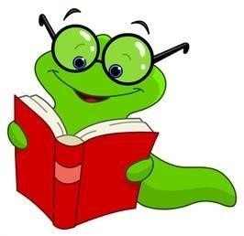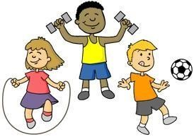

Please could the children wear their PE kits into school on their PE

days, which will

be

on

Tuesdays

. Please ensure PE kits are suitable:

House coloured T

-

Shirt (not football shirts), shorts, leggings or

tracksuit trousers and

trainers or shoes that are suitable for sport.

Please encourage your child to read regularly and hear them read at

home; it is important to help with difficult words, expression and

understanding of the text. Your child will benefit from being asked questions

about what they have read, as this develops their comprehension.

Please encourage your child to learn and practise their timetables.

We will focus on the 2, 5 and 10s times tables this half term. The

y

also need to learn the related division facts as well as recall the

multiplication facts quickly.

The children will be sent home with their logins and passwords for

Times Tables Rockstars. This can be accessed at home

as well as at school to

help improve their maths skills.

Home learning will be posted directly to the Class Dojo page as well as in their home learning books. Home learning will be set on Fridays and will be due in on the following Thursday. Please encourage your child to complete their home learning in the exercise book provided. Alternatively, they can post a picture of it on their Dojo portfolio.

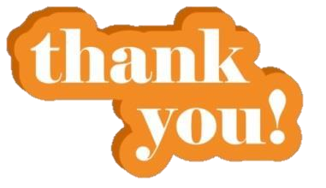

Important updates will be posted to Class Dojo often, so please check regularly. Please don’t hesitate to message me on Dojo or catch me at the end of the day if you have any questions or concerns. Thank you, Miss Jones 😊