Art:
Could you make a model of your Willy Wonka sweet invention?
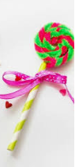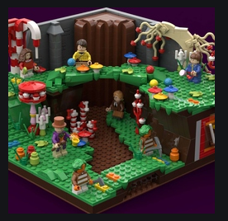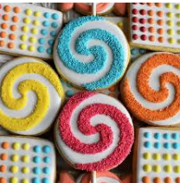
Use any materials that you like…playdough/papier mache/junk modelling/lego,etc
*Maybe you could create your very own sweet shop?*

