**Activity 5**

**WE ARE WRITERS!**

**Writing workshop**

*Look at each of these images taken during World War 2.

* What might be happening?

* How might these people be feeling?

**Write what you imagine the people are saying using inverted commas.** 

OR…

**Write a really spectacular descriptive sentence that starts with a fronted adverbial.**

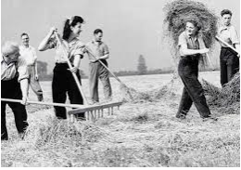 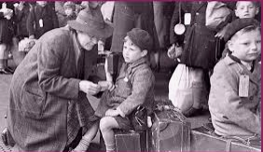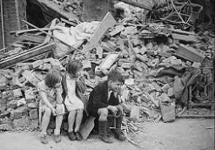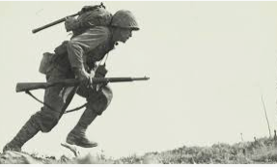

E.g. As the fog of artillery fire cleared, I launched myself out from the gully.