**Activity 5:**

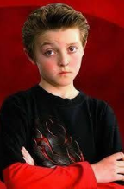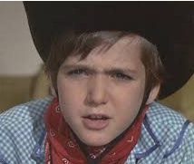

**TV the BIG debate!**

**NB! You need a grown up or sibling to do this activity with!**

In Charlie and the Chocolate Factory a little boy called Mike Teavee just LOVES to watch TV. The Oompa Loompas are not so sure this is such a good idea!

**1.Read the book extract of a song that the Oompa Loompas wrote.**

*Do you agree with the Oompa Loompas?

* Can you think of some reasons why watching TV **can be useful and good**?

**2. WE are going to have a debate! You are going to choose to share your opinion in role as one of the characters listed on these character cards. Your partner can ask you questions whilst you are ‘in role’ as that character.**

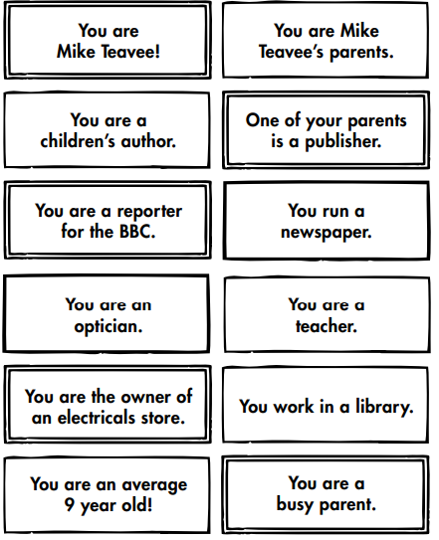

Which character are you?

WHY does your character think that?

Is your character FOR or AGAINST TV?