# Minibeasts

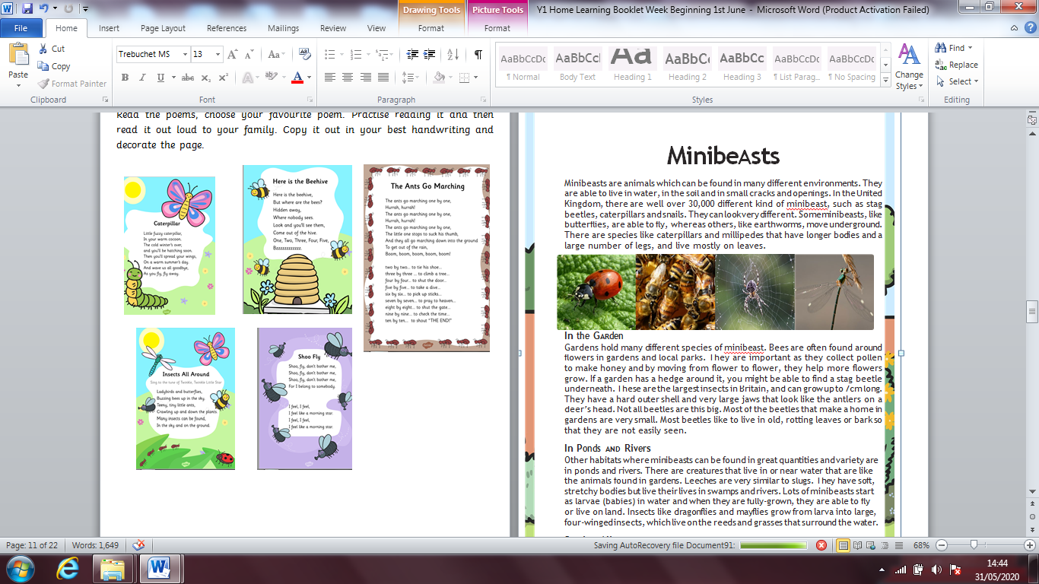Minibeasts are animals which can be found in many different environments. They are able to live in water, in the soil and in small cracks and openings. In the United Kingdom, there are well over 30,000 different kind of minibeast, such as stag beetles, caterpillars and snails. They can look very different. Some minibeasts, like butterflies, are able to fly, whereas others, like earthworms, move underground. There are species like caterpillars and millipedes that have longer bodies and a large number of legs, and live mostly on leaves.

## In the Garden

Gardens hold many different species of minibeast. Bees are often found around flowers in gardens and local parks. They are important as they collect pollen to make honey and by moving from flower to flower, they help more flowers grow. If a garden has a hedge around it, you might be able to find a stag beetle underneath. These are the largest insects in Britain, and can grow up to 7cm long. They have a hard outer shell and very large jaws that look like the antlers on a deer’s head. Not all beetles are this big. Most of the beetles that make a home in gardens are very small. Most beetles like to live in old, rotting leaves or bark so that they are not easily seen.

## In Ponds and Rivers

Other habitats where minibeasts can be found in great quantities and variety are in ponds and rivers. There are creatures that live in or near water that are like the animals found in gardens. Leeches are very similar to slugs. They have soft, stretchy bodies but live their lives in swamps and rivers. Lots of minibeasts start as larvae (babies) in water and when they are fully-grown, they are able to fly or live on land. Insects like dragonflies and mayflies grow from larva into large, four-winged insects, which live on the reeds and grasses that surround the water.

## Staying Alive

Most minibeasts do not have a skeleton like humans; they have a shell on the

outside of their bodies to protect them. However, some minibeasts’ bodies are only

soft. These animals often try to hide or blend in with the plants around them so

that they are not seen. The bodies of slugs are completely soft and birds and

other predators can easily eat them. Snails carry a hard shell on their backs and

are able to pull back into this shell if they feel threatened. Though it is not very

popular in the UK, snails are eaten by people in some countries in the world.