**Activity 5:**



**Fairtrade Reading Comprehension**

Today we are going to read and find out about Fairtrade food. 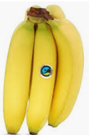

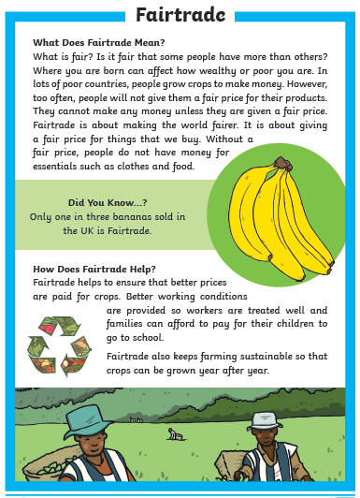

Activity 5:

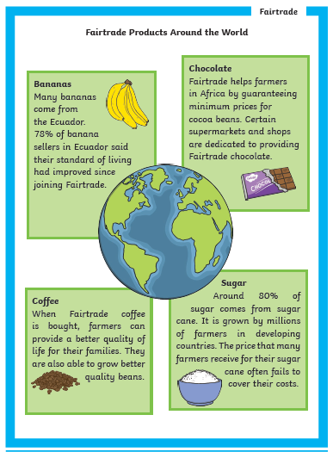

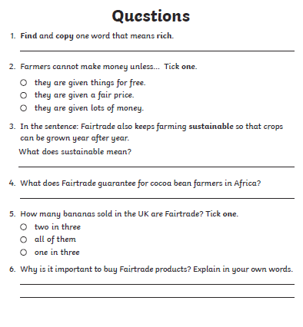

Something to find out about / discuss with a grown up:

**If you were the Prime Minister what would you do to encourage other World Leaders to always pay a fair price for all goods/trade ?**

**Fair trade products can be expensive. How could supermarkets help less wealthy people buy Fairtrade products?**

**Is it possible to buy FAIR TRADE products for things other than food?**

