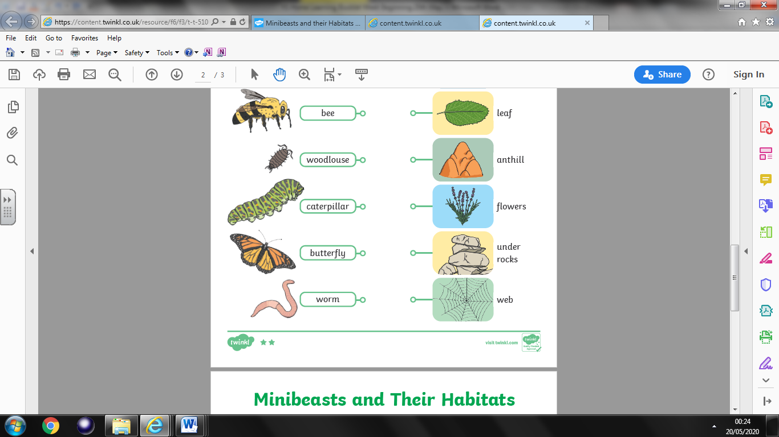

Science Activity 5

Draw your junk model minibeast.

Write and description for your minibeast.