**Activity 4:**

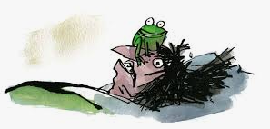

**Write like Roald Dahl!**

1. Today we are going to start by reading the next chapters in the book which describe the dreadful tricks that ghastly Mr and Mrs Twit play on each another.

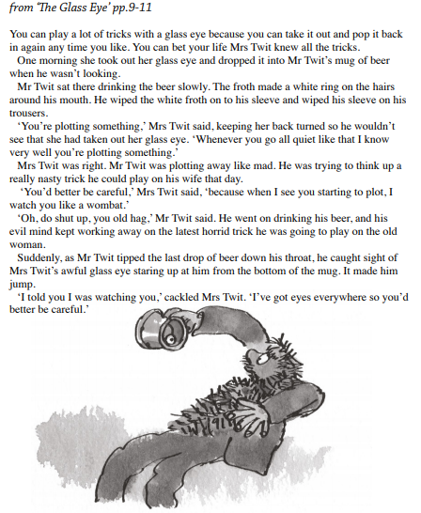

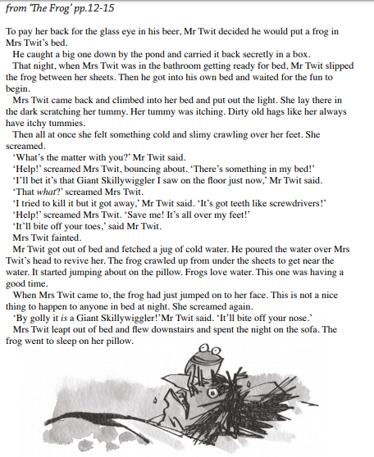

1. We are going to invent our own trick and write a new chapter.
2. Let’s start by thinking about how Roald Dahl structures these chapters about ‘the tricks’.

Look back at Extract 1,’The Frog’. Grab some coloured pens or pencils. You can see which colours you will need in the chart below.

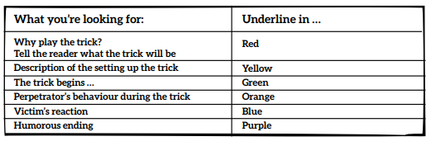

1. Look carefully at the chart. Use the appropriate coloured pen and read back through ‘The Frog’ and ‘The Glass Eye’, highlighting the parts you are looking for. This will help you to see that there is a structure to the way Roald Dahl has organised his ideas.

Now that you have carefully analysed the structure of these ‘trick’ chapters you are going to come up with your own new ‘trick chapter’!

1. You can use this writing frame on the next page to help you plan and structure your ideas.

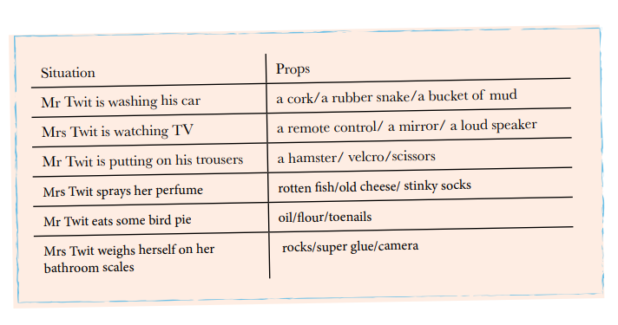

Some inspiring ideas!



