**Writing a VE Day DIARY entry.** 

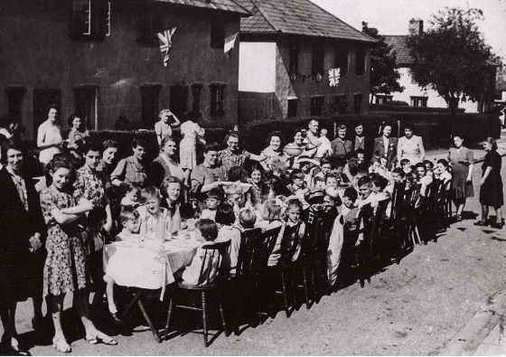

**Today I would like you to imagine yourself at a VE Day celebratory street party on May the 8th 1945!**

Maybe... as an 8/9 year old child (who lives in the important port of Southampton) houses in your St Denys street were bombed during the blitz.

Maybe... you were evacuated to Dorset to live on a farm by the sea and you missed your Mother terribly.

Maybe... now that VE Day is finally here, you are excited that soon you will finally be reunited with your Father who has been fighting in France.

Maybe...you are terribly excited that today you will have a street party with flags and jelly and cake and sweets because people have saved up their rations in anticipation of this memorable day!

Just a few ideas to get you started!

* Use the worksheet photo and word bank to help you.

* Start your diary entry with 'Dear Diary' and write using the 1st person ( I...)

**WORD BANK:**

**Here are some useful words:**

**‘The Blitz’ German England enemy**

**bomb blitz Churchill**

**Hitler black-out evacuee soldiers**

**letters rations/ rationing**

**Army fight / fought King George VI wireless**

**Union Jack flags street party celebration** 