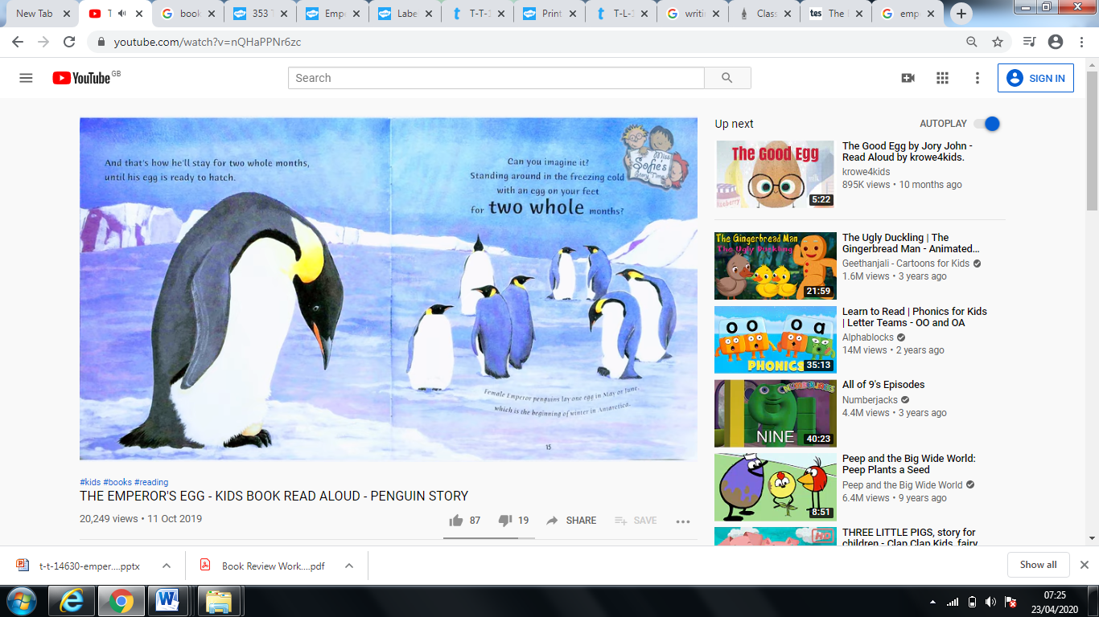

What do you think the male emperor penguin is thinking?

Write a sentence in the thinking bubble.