**Activity 4:** 

**Writing your favourite recipe!**

Every family has their favourite thing to eat, so what is yours?

Has there been a particular recipe that you have learnt to cook yourself during lockdown? Maybe you have a recipe handed down through your family? Maybe you have created a lockdown recipe using limited ingredients?

Now is your chance to help create the Class4-tastic section of the St Denys Corona Cookbook!

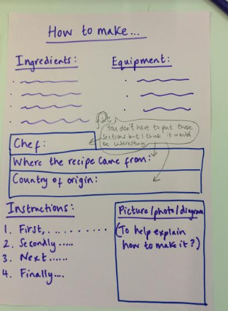

1. How you write up your recipe is your choice but I have photographed a suggested layout.

2. Take care to include the features of instructions in your recipe. Don’t forget imperative verbs and time connectives.

3. Be really creative with your presentation!

1. If you are a member of the Dojo Cookery Club send your recipe to Miss Rawles OR keep your finished recipe and bring it to school when we return so it can go in the school cookbook.