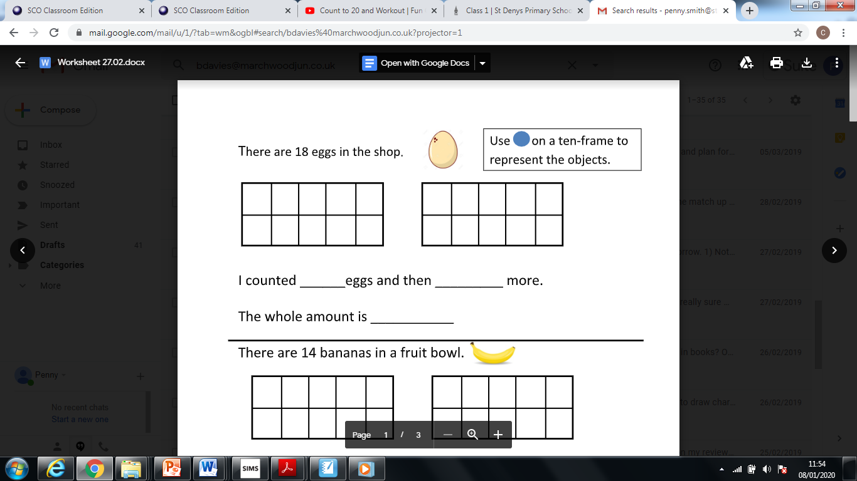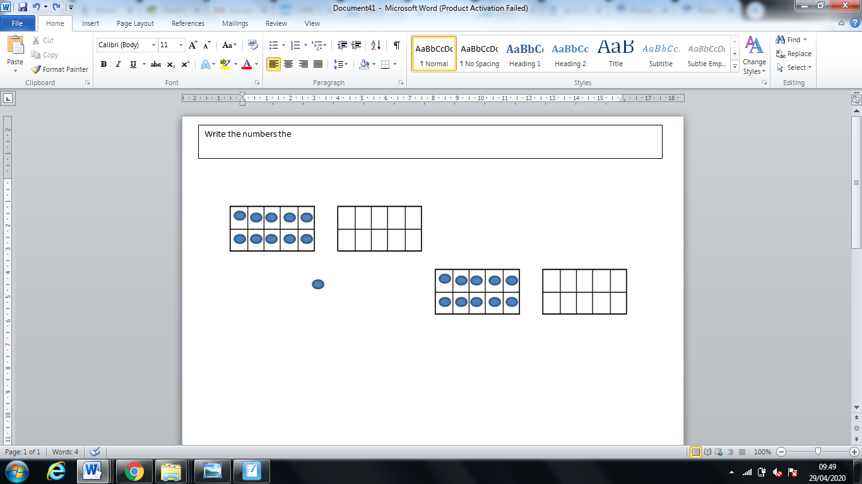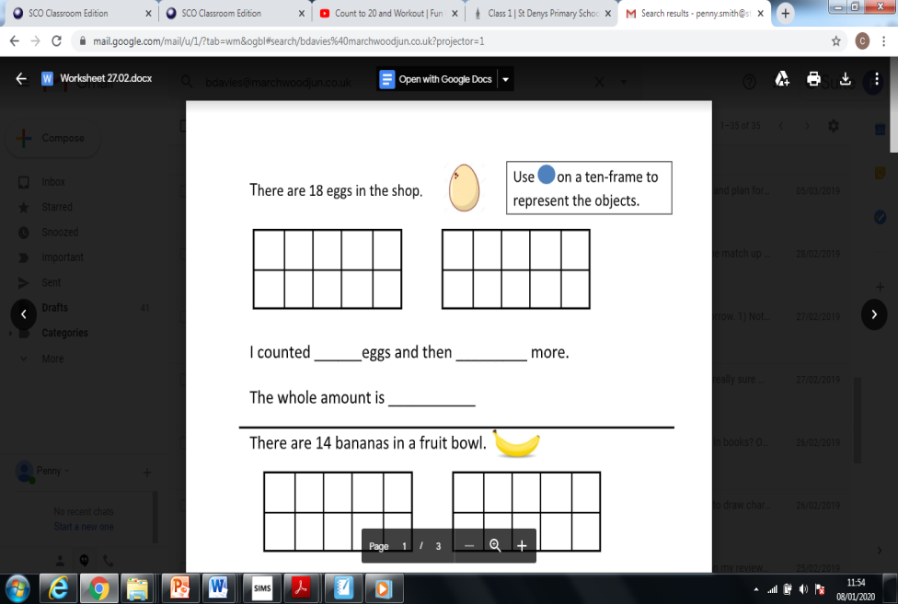

The number is

ones.

tens

The number is

ones.

tens

The number is

ones.

tens

The number is

ones.

tens

Write the numbers the represent