Can you make up your own subtraction stories like this one?

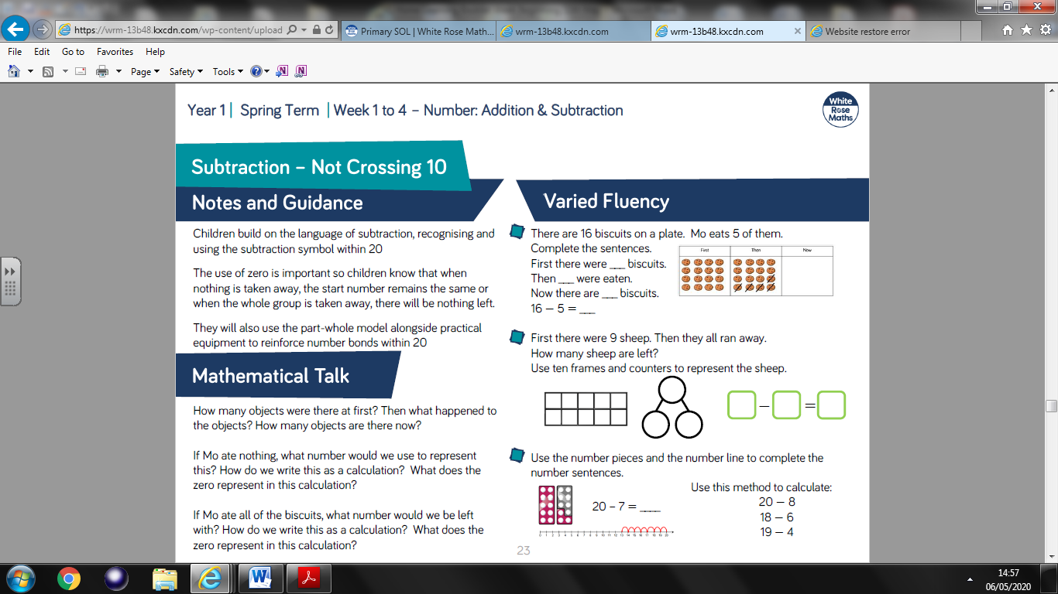

You can use objects around the house or draw objects to help you.

Do as many as you like.

First there ___

Then _____

Now there are _____

* =

--------------------------------------------------------------------------------

First there ___

Then _____

Now there are _____

* =