Activity 3
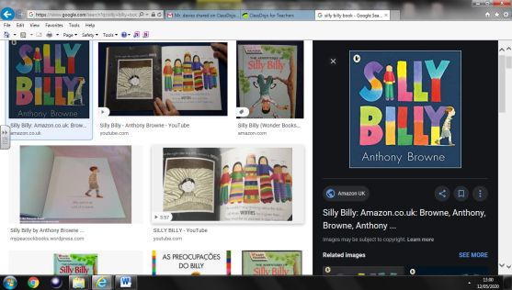
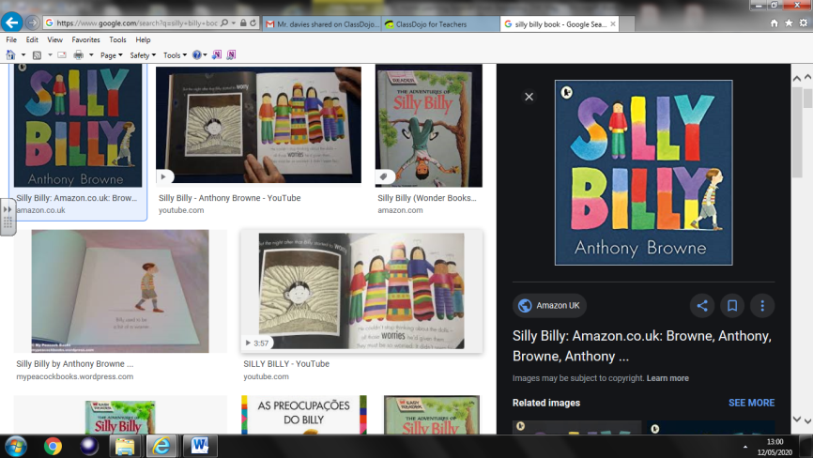
Silly Billy by Antony Browne
Can you remember the things Billy worried about?
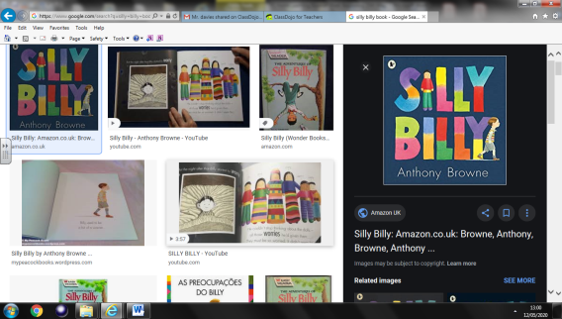
How do you think the worry dolls helped Billy stop worrying?
Think of something else Billy could worry about.
Draw a picture and write a sentence to go with your drawing

