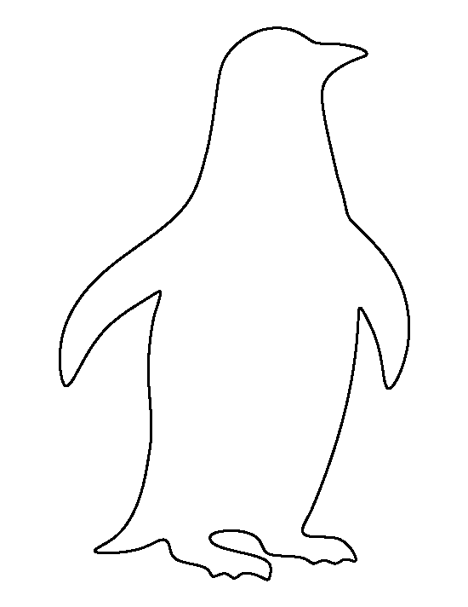

**What do you know about Emperor Penguins?**

Write down all the facts you know around the penguin.

|  |
| --- |
| Do you have any questions about Emperor Penguins that you don’t know the answer to? Write down anything else you would like to find out. Remember questions have question marks at the end. |
|  |
|  |
|  |
|  |