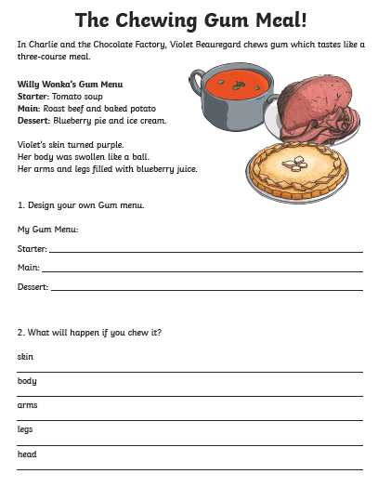

Remember to use capital letters, full stops and any other punctuation you may need!