**Activity 3:**

**What are Similes and Metaphors?**

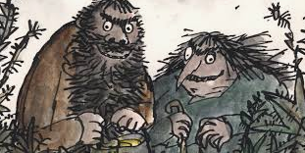

“ If you have good thoughts they will shine out of your face **like** sunbeams.”= SIMILE

“It grew in spikes that stuck out straight **like** the bristles of a nail brush.”=SIMILE

“The beard **was** a hairy jungle.” = METAPHOR

* Roald Dahl uses similes and metaphors to help us build up a detailed picture of how Mr and Mrs Twit look.
* What is the difference between a simile and a metaphor?

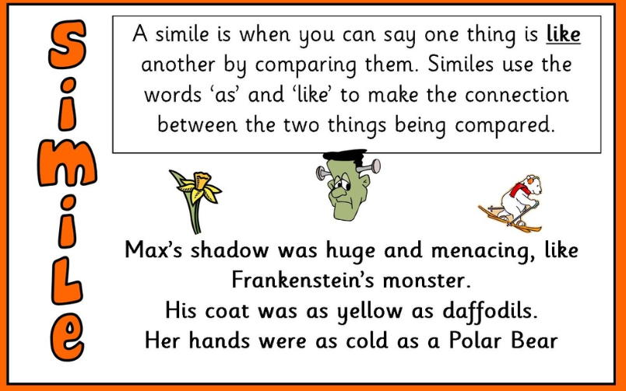

A simile compares.

Similes use the word ‘like’ or ‘as'.

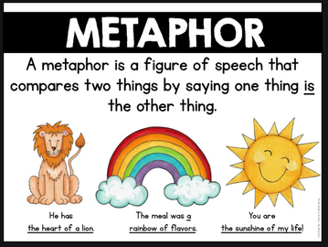

Metaphor = A comparison in which one thing is said to be another.

If the sentence contains a simile colour it yellow.

If the sentence contains a metaphor colour it blue.

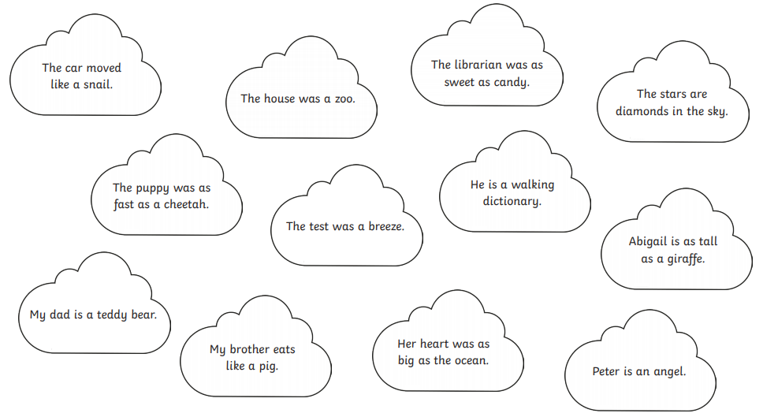

Now try competing the sentences using a simile or metaphor:

1. Mr Twit trudged down the road like…………………………………………………
2. The cornflakes in the beard were like……………………………………………
3. Their garden was ………………………………………………………………………………..
4. Mr Twit’s table manners were like……………………………………………………
5. Mrs Twit’s glass eye …………………………………………………………………………..
6. He was as smelly as ……………………………………………………………………………

