**Activity 3:**

**Today we are going to start to write instructions for a recipe!**

Can you choose the correct imperative verb and order the instructions so that the recipe will make an omelette? Or will you have an eggy mess?!

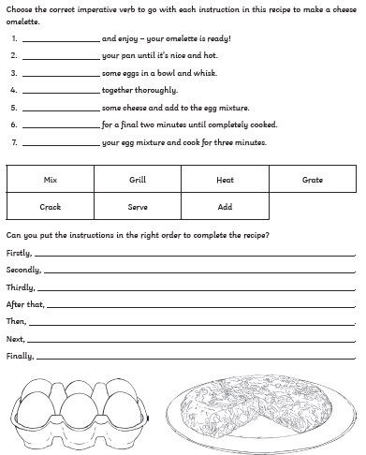

Did you make the omelette? Send us a photo on Dojo!

**\* You could always try writing a set of recipe instructions for something else! E.g. how to make a cup of tea.**