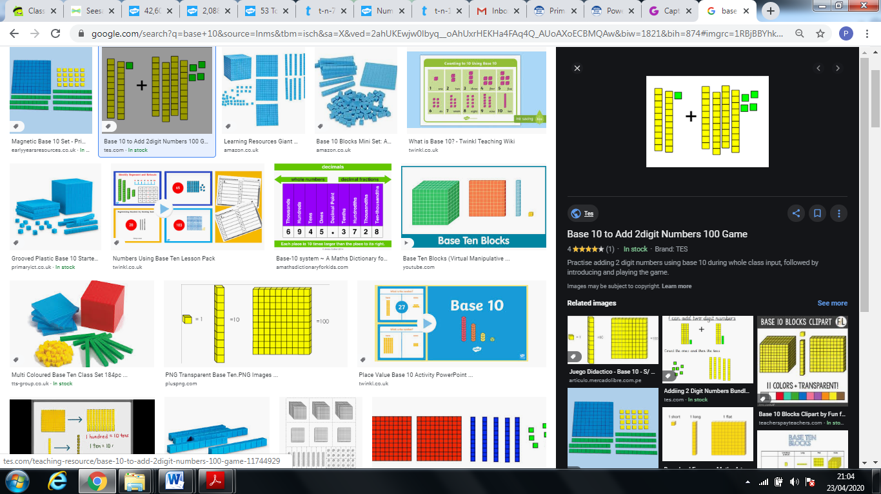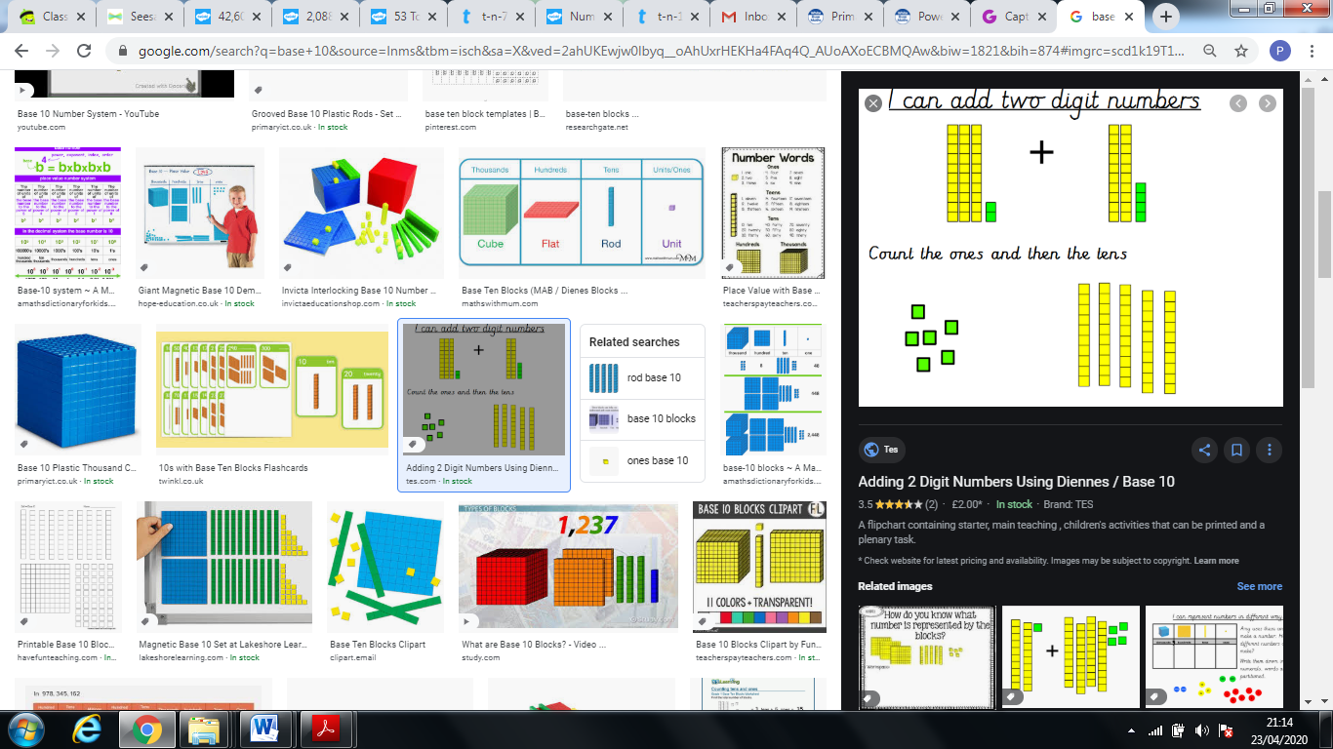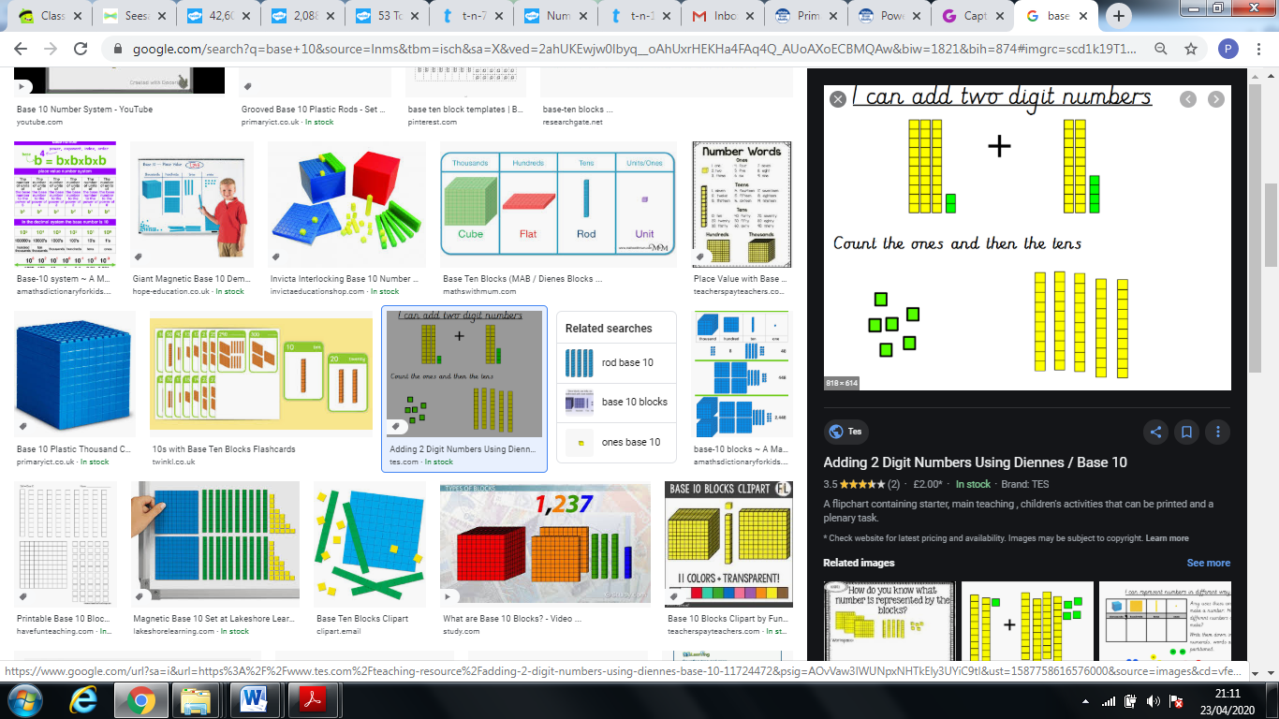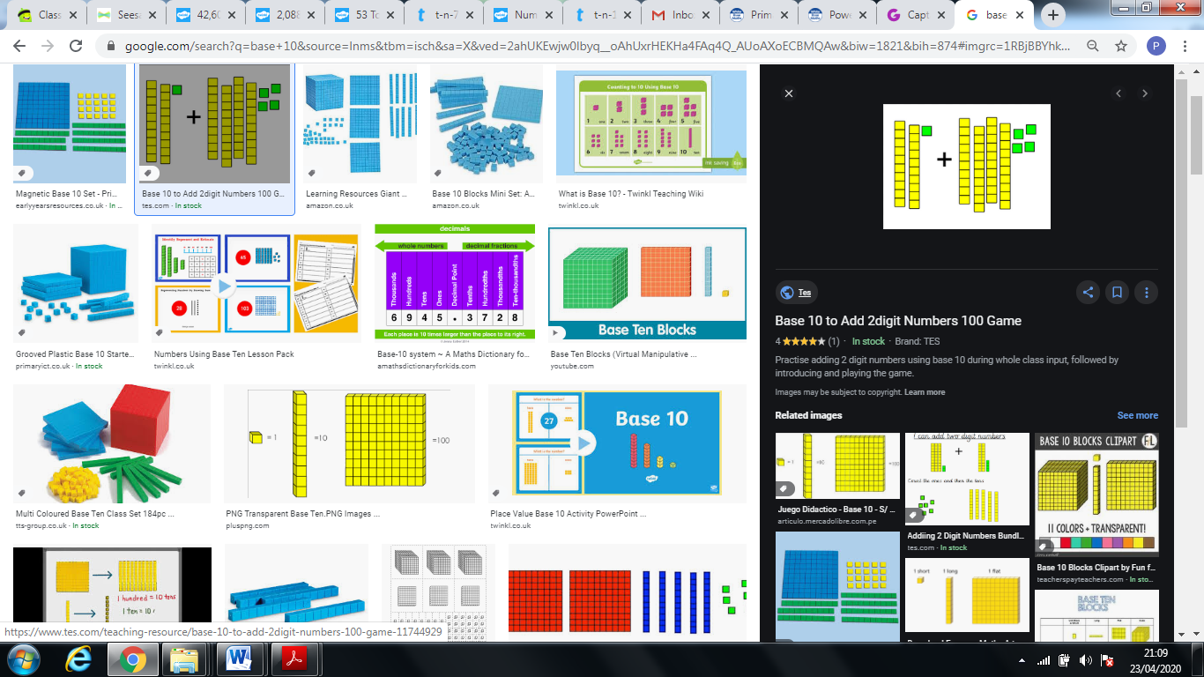

There are _________ tens.

There are _________ ones.

The whole amount is _________

There are _________ tens.

There are _________ ones.

The whole amount is _________

There are _________ tens.

There are _________ ones.

The whole amount is _________

There are _________ tens.

There are _________ ones.

The whole amount is _________

There are _________ tens.

There are _________ ones.

The whole amount is _________

**What number is being represented?**

**How many tens are there? How many ones are there?**