

**Silly Sentences need the Sentence doctor**

Read the sentences. Tick the sensible sentences.

Put a cross by the silly sentences.

Highlight the mistake in each sentence.

Change the silly sentences so they make sense.

The first one has been done for you.

🗸 x

1. The rain fell from the grass. [ x ] The rain fell from the sky.

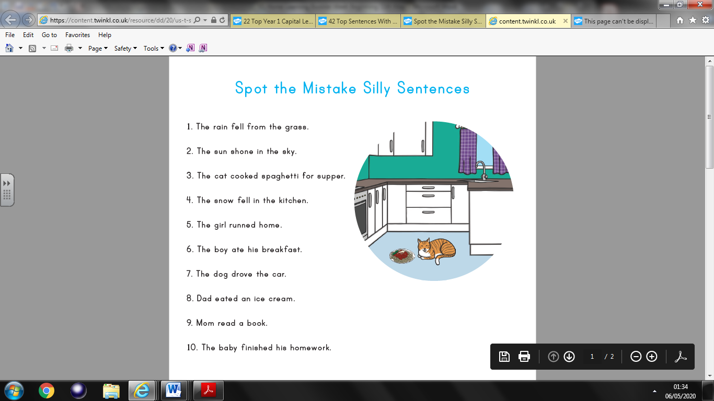2. The sun shone brightly. [ ]

3. The cat cooked spaghetti for supper. [ ]

4. The snow fell in the kitchen. [ ]

5. The girl runned home. [ ]

6. The boy ate his breakfast. [ ]

7. The dog drove the car. [ ]

8. Dad eated an ice cream. [ ]

9. Mum read a book. [ ]

10. The baby finished his homework. [ ]