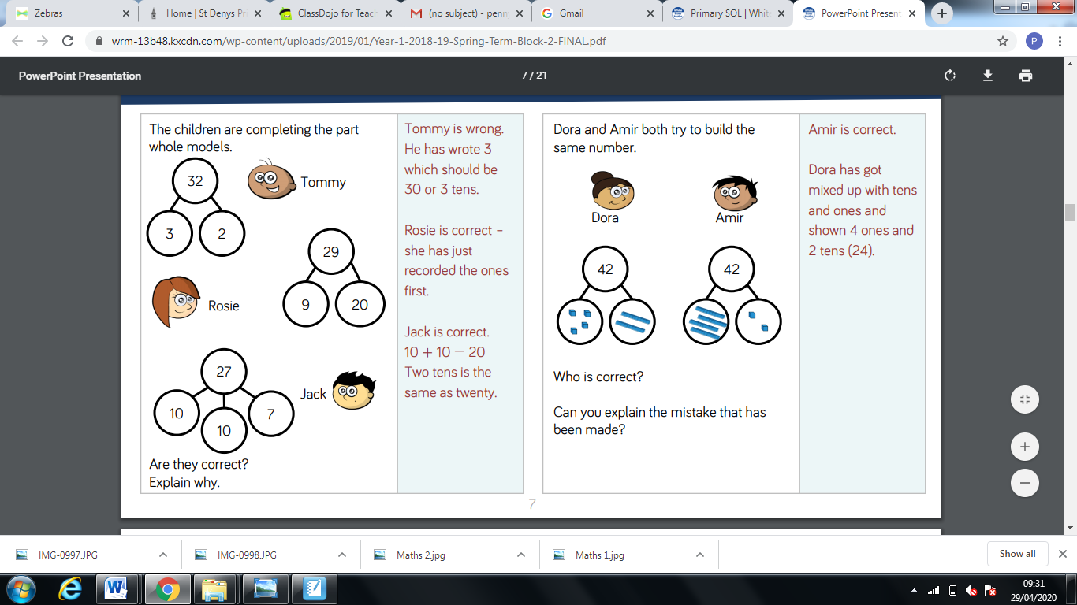

Have a go at solving these problems. Remember to look carefully at each one.