|  |  |  |  |
| --- | --- | --- | --- |
|  |  |  |  |
|  |  |  |  |
|  |  |  |  |

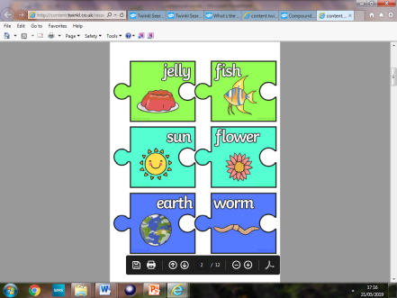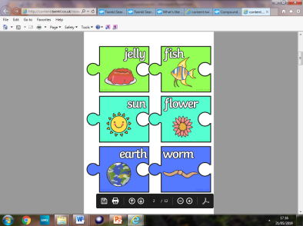

**Compound words**

A compound word is a word made by joining two other words. For example the words hand and bag join together to make the word handbag.

Cut out the words and join to make a new compound word.

One has been done for you. and = earthworm