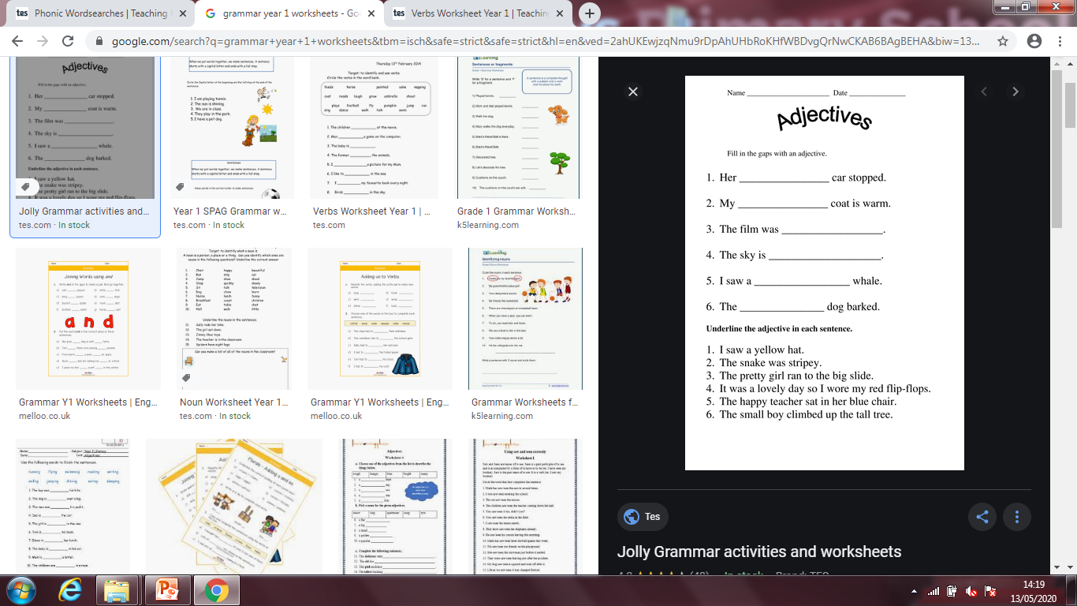

Remember an adjective is a describing word that tells us about the noun.

The **hungry** boy ate his dinner.