**Activity 2 Instructions and Recipes**

Today we are going to think about recipes.

Recipes are the type of instruction that is used to explain how to prepare a particular food.

So…what are the key features of instructions?

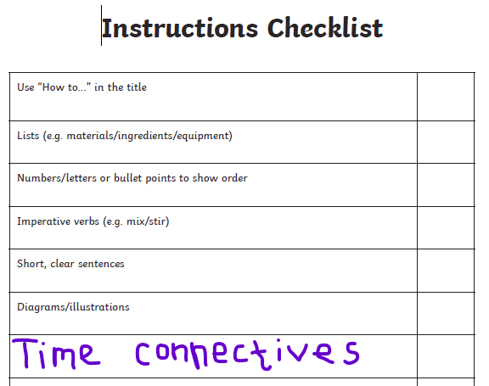

Time connectives are words like: first, next, finally. They help explain the order/time.

(Sorry about the dodgy writing!)

Time connectives and imperative verbs are key features of instructions. Imperative verbs are bossy because they tell people what to do!Time connectives tell us WHEN something is happening.

1. Have a go at these quick activities to remind you what imperative verbs and time connectives are.

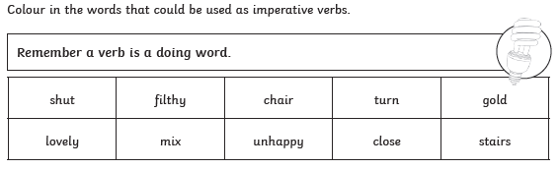

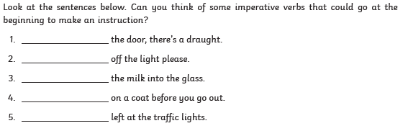

Colour in the time connectives:

|  |  |  |  |
| --- | --- | --- | --- |
| Firstly | Cut | Meanwhile | Banana |
| Put | Finally | Next | After that |

1. Find some highlighter / felt tip pens and look at the recipe for making pancakes on the next page.
2. Use the instructions checklist and highlight the features of instructions that you can see in the pancake recipe. You could use a different coloured pen for each feature and make a key by colouring that box on the instructions checklist.
3. Are there are features from the checklist that were missing? Can you add them on to the pancake recipe?

