My Willow Pattern Plate Cartoon Story
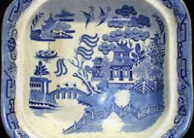
Once upon a time, a long time ago in China…

