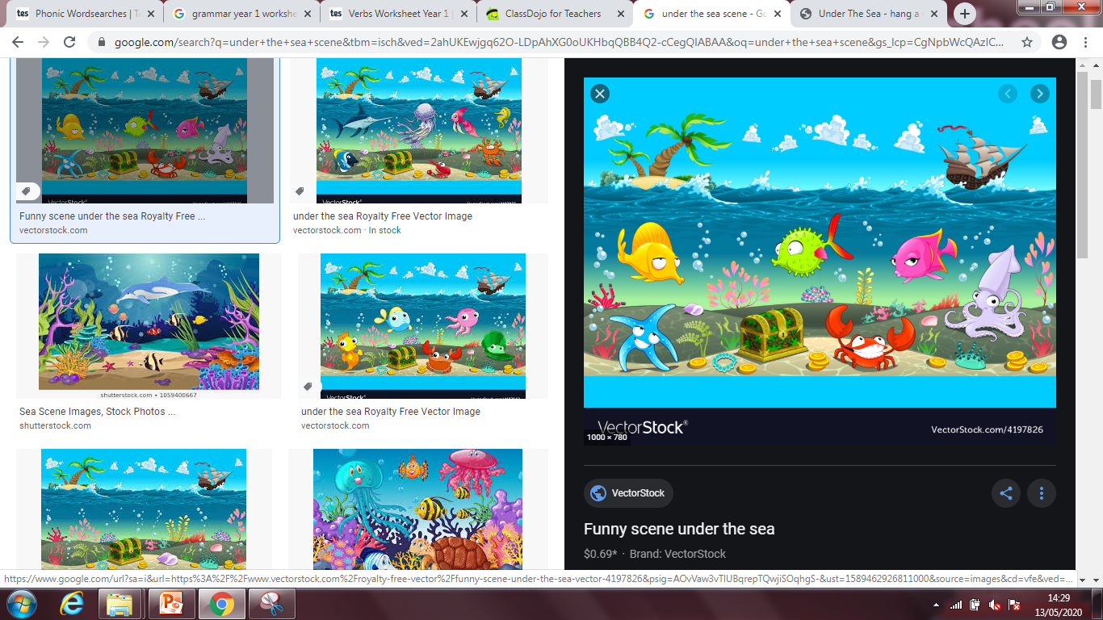

Look carefully at the picture below.

What can you see?

What do you think the fish are doing?

Where is the pirate ship heading?

What is in the treasure chest?

Does anyone live on the island?

Write some sentences about the picture and what you can see.

Can you write a story based on under the sea?