Look at this picture.

Write a story about the picture.

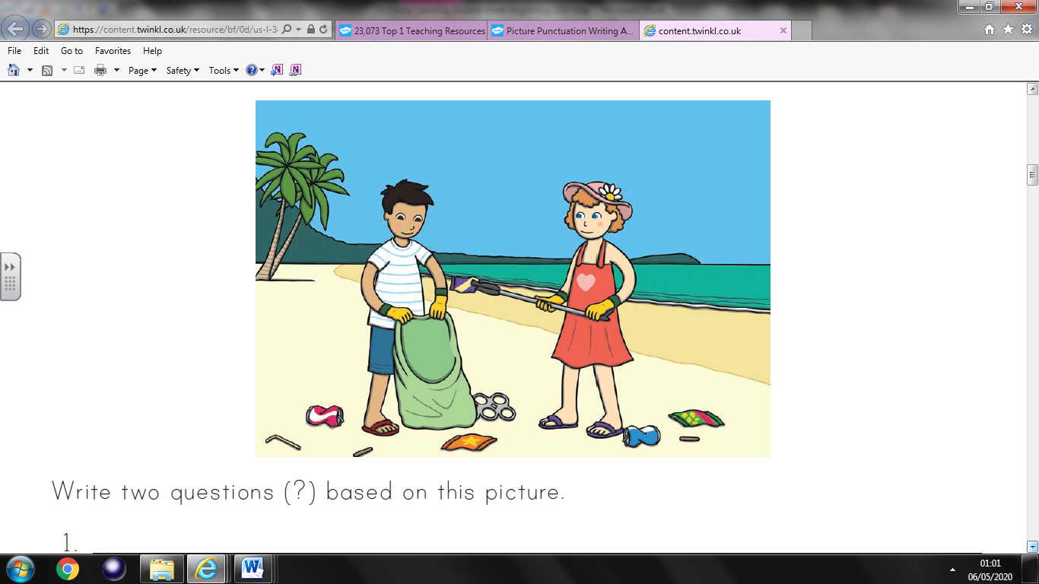

**Before you start think about:**

Where the children are and what they are doing?

What have they found?

What are they going to do with the things?