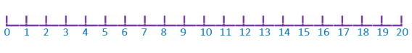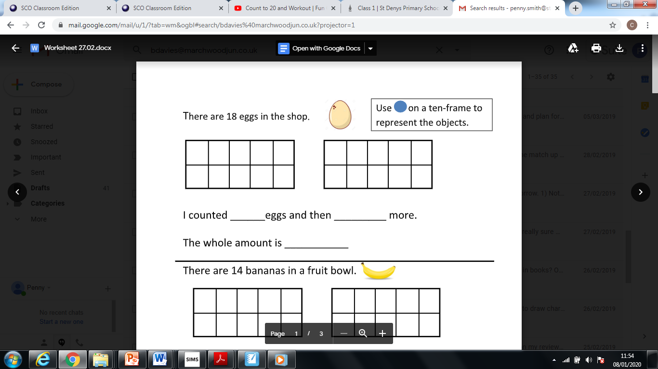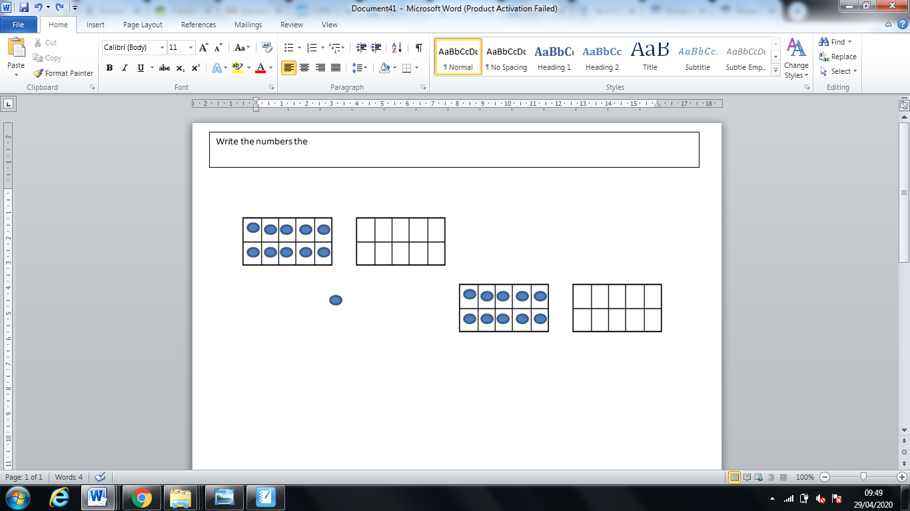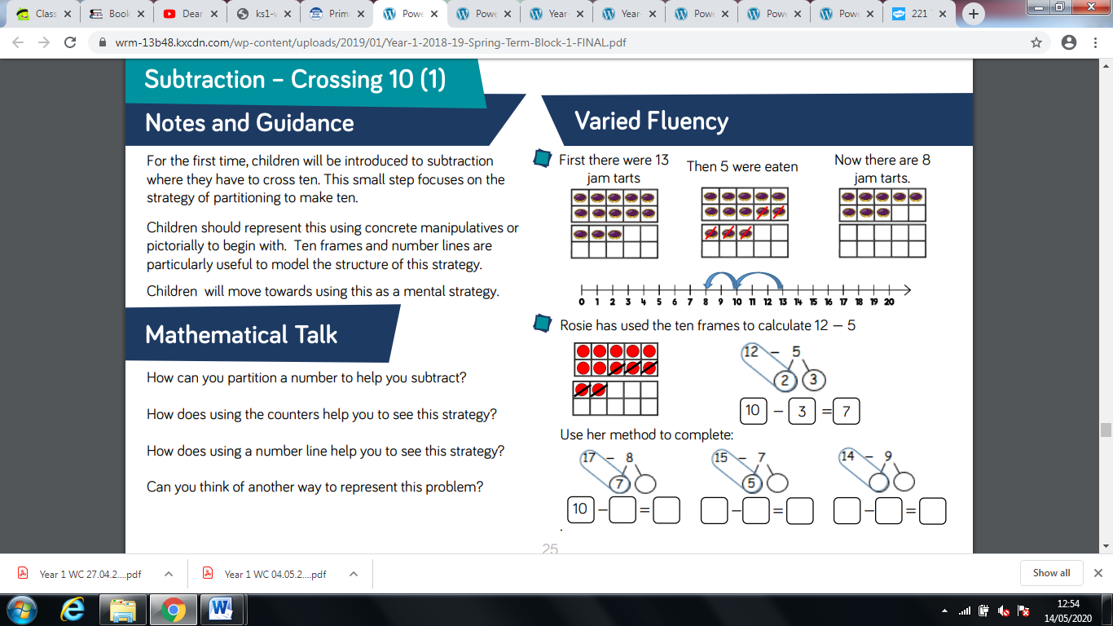Can you work out these subtraction stories and show your working out on a number line too?

=

-

Now there are

___ monkeys.

Then 5 ran away.

First there were 12 monkeys.

-

=

Now there are

________ cars.

Then 8 drove away.

First there were 17 cars.

8

=

13

5

-







=

-

Now there are ____ birds.

Then 7 birds flew away.

First there were 16 birds.

-

=

Now there are ____ balloons.

Then 7 were popped.

First there were 14 balloons.

-

=

Now there are

____ lollipops.

Then 6 got eaten.

First there were 13 lollipops.