|  |
| --- |
|  |
|  |
|  |
|  |
|  |
|  |
|  |
|  |
|  |
|  |
|  |
|  |
|  |
|  |

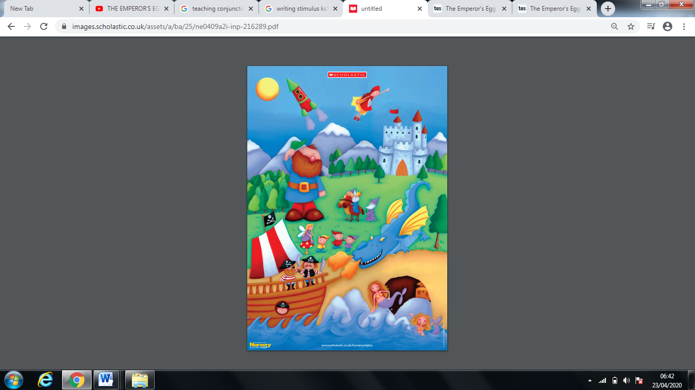

**Remember:**

Capital letters

Full stops

Finger spaces

Cursive handwriting

Adjectives

One idea at a time!