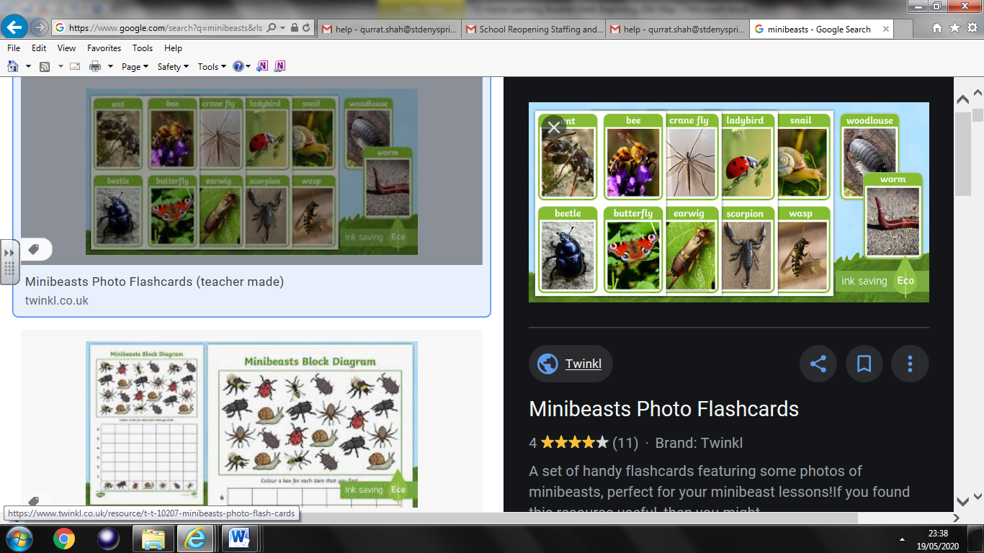

Science Activity 1

Minibeasts

Name and draw as many minibeasts as you can