**Activity 1**

**Willow Pattern Plate**

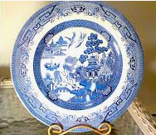

**Have you ever seen a plate that looks like this before**?

It’s a pattern called ‘Willow Pattern’ based on an imaginary scene in China many years ago.

My Granny and Grandad had a whole set like this when I was little.

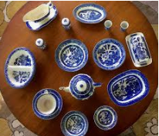I can remember looking at the pictures as I ate my breakfast toast.

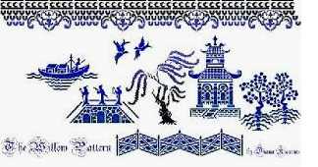

If you look closely at this ideas board for the design you can just about see 3 figures of people on a bridge, a figure on a boat, a palatial looking house, 2 birds and some trees – one looks like the whomping willow at Hogwarts.

Listen to ( or just read) this story poem that Tony Mitton wrote, inspired by looking at the pictures on his willow pattern plate. It is set in China a long time ago.

https://www.youtube.com/watch?v=4VwAYc7dsUE

**Willow Pattern Plate by Tony Mitton**

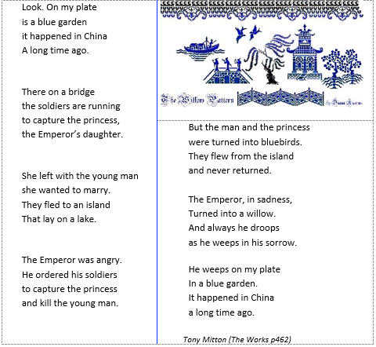

**Activity:**

Your job today is to retell the story using the cartoon style story board on the next page.

Use speech bubbles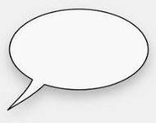 for what the characters might say e.g**. Soldiers, you must capture the Princess and kill that young man!** and write the action (what is happening) in the box section below the illustration.

**I have given you 7 empty cartoon boxes to write in but it doesn’t’ matter if you don’t use them all.**