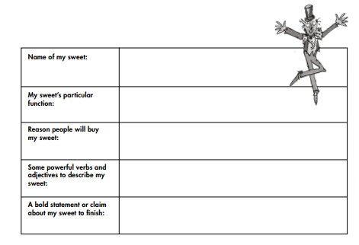

**? What does your sweet do when it is eaten? E.g. change flavour, turn your face a different colour?**

**? Why would someone want to buy it? = the taste…**

**is it gloriumptious, wondercrump, splendiferous,**

**whipple-scrumotious?**

