Poems that are written in praise of something or someone are called an ‘ode’.

So how can I tell when a poem is not just a poem but an ode?

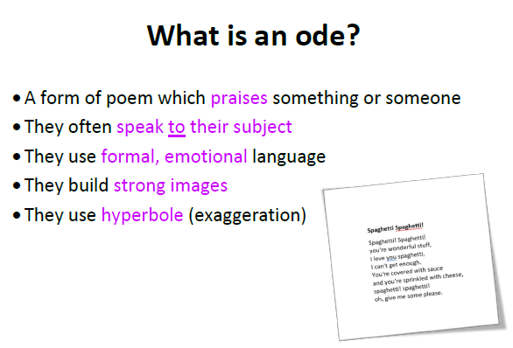

An ode can be serious or silly.

Shakespeare wrote a lot of ODES

Inside his 9th Symphony the composer Beethoven wrote a section called ‘ODE to Joy’ – check it out on YOUTUBE as I expect you will recognise it!

4. Read these other odes.

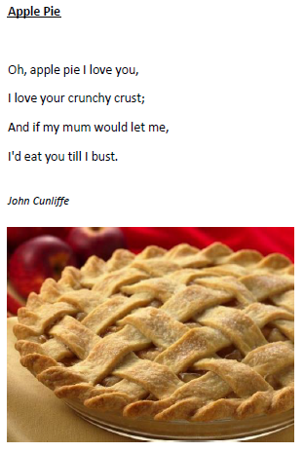 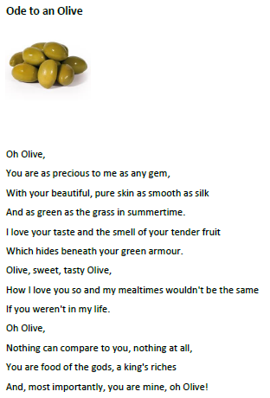

5. Now try answering the questions inside the speech bubbles below . Number your answers and remember to write full sentences with full stops and capital letters. 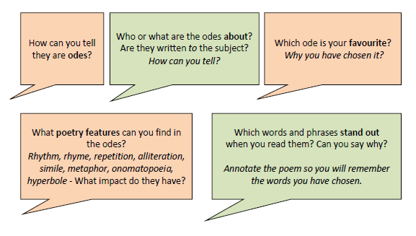

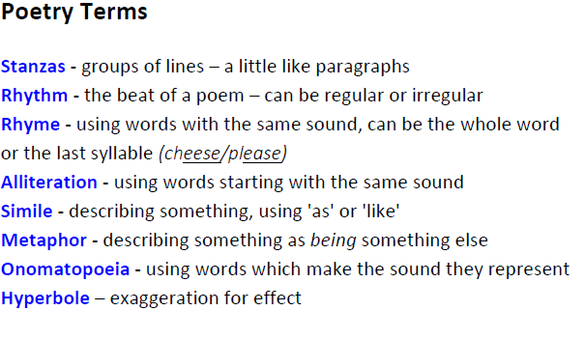

Most of these features are tricky to explain virtually via our booklet! Use this guide to help you but don’t worry if you just stick to rhythm and rhyme.