**Activity 1 : Food Glorious Food!**

We are going to start off our food themed week by reading this poem by Jack Prelutsky. It’s all about my favourite type of pasta!

Write the answers to these questions in your book/on paper.

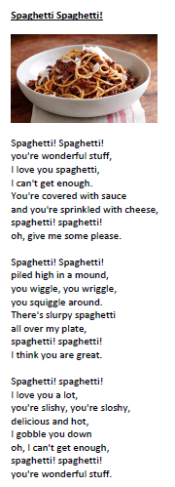

1. What do you like about the poem?

2. What patterns do you notice?

3. Which is your favourite phrase?