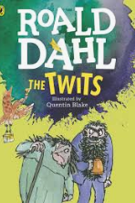

**Activity 1:**

**We are going to be using this brilliant book by Roald Dahl for our English.**

1. Read these 5 pages from the start of our book describing Mr Twit. Prepare to be disgusted!

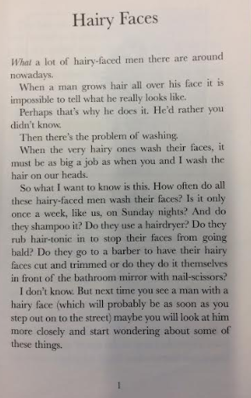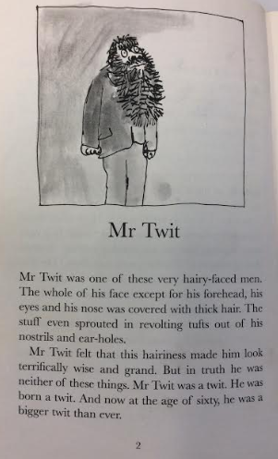

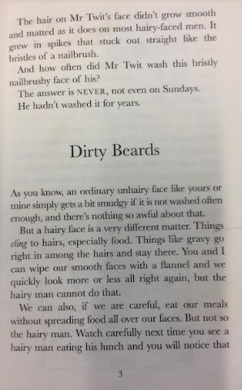 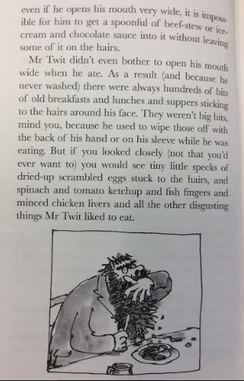 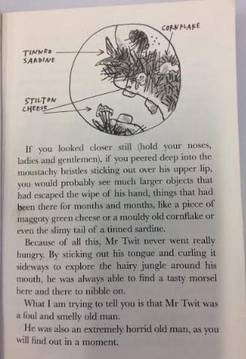

**2.**

**Revolting isn’t he?**

**Now turn over to the next page to answer questions about what you have read.**

**Write your full sentence answers in a book/ on some lined paper.**

1. What was revolting about Mr Twit’s beard?
2. Why is the word NEVER in capital letters?
3. “His hair grew in spikes that stuck out straight like the bristles of a nailbrush”. When a writer likens something to something else it is called a S_M_ L _.
4. Why was Mr Twit never hungry?
5. Can you find / think of some adjectives to describe the decaying food?
6. Mr Twit’s beard is described as being a ‘hairy jungle’.

What does the word ‘jungle’ make you think of?

How is Mr Twit’s beard like a jungle? Why do you think Roald Dahl used that image of a jungle?

**Mr Twit**

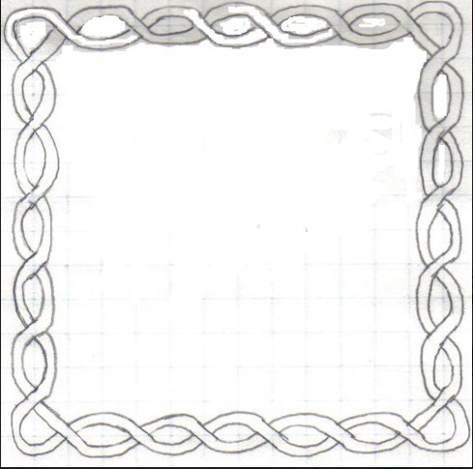

**7. Draw your own portrait of Mr Twit here.**

What could he be saying?

**8. Add it into the speech bubble.**